2025

**Business Plan**



Δ3D - an app created for 3D modeling

Smart Mobile Application Development (2025-2026) Group 10

Contents

1.APP Overview 6

1.1 Application Introduction 6

1.1.1 App Name and Core Functionality Description 6

1.1.2 Technical Principle . 6

1.1.3 Platform Positioning. 8

1.2 Product Features 8

1.2.1 Real-time Camera 3D Scanning Functionality 8

1.2.2 Interactive 3D Model Editing and Preview 8

1.2.3 Model Export and Sharing Capabilities 8

1.2.4 Cloud Storage and Synchronization Features 9

1.3 Technical Architecture 9

1.3.1 3D Reconstruction Algorithm Technology Stack 9

1.3.2 Mobile Performance Optimization solutions 10

1.3.3 User Interface Design Philosophy 10

2. Unique Selling Proposition 11

2.1 Core Competitive Advantages 11

2.1.1 Technological Breakthrough in Mobile Real-time 3D Modeling. 11

2.1.2 Accessibility Without Professional Equipment Requirements 12

2.1.3 Balance Between High-Precision Modeling and User-Friendly Operation 12

2.2 Differentiation Strategy 13

2.2.1 Differentiation from Professional 3D Software 13

2.2.2 Technical Advantages Over Existing Mobile 3D Applications 13

2.2.3 Cost-Effectiveness Advantage Analysis 14

2.3 Value Proposition 14

2.3.1 Providing Professional-Grade 3D Modeling Experience for Ordinary Users 14

2.3.2 Lowering Barriers to 3D Content Creation 15

2.3.3 Supporting AR/VR Content Ecosystem Development 15

3. Target User Persona 15

3.1 Primary User Groups 15

3.1.1 Creative Designers: Rapid Prototyping Needs 15

3.1.2 Educators: Teaching Demonstration and Interactive Requirements 16

3.1.3 E-commerce Sellers: Product 3D Display Needs 16

3.1.4 Individual Users: Memorabilia and Creative Sharing Demands 16

3.2 User Needs Analysis 17

3.2.1 Pain Point Identification: Complexity and Cost of Traditional 3D Modeling 17

3.2.2 Use Cases: Design, Education, E-commerce, Entertainment 17

3.2.3 User Behavior Patterns: Mobile-First, Instant Gratification Needs 18

3.3 User Acquisition Strategy 19

3.3.1 Early Seed User Cultivation 19

3.3.2 Community Building and Word-of-Mouth Marketing 19

3.3.3 Partner Referral Programs 19

4. Market Analysis 19

4.1 Market Size and Trends 20

4.1.1 Global 3D Modeling Software Market Size 20

4.1.2 Mobile AR/VR Application Market Growth Trends 21

4.1.3 Current State of 3D Applications in China’s Android Market 22

4.2 Competitive Landscape Analysis 22

4.2.1 Direct Competitor Analysis (Existing 3D Scanning Apps) 23

4.2.2 Indirect Competitor Analysis (Professional 3D Software, Online Tools) 23

4.2.3 Competitive Advantage and Disadvantage Comparison matrix 24

4.3 Market Opportunity Identification 24

4.3.1 New Opportunities Brought by Technological Developments 24

4.3.2 Unmet User Demand Areas 25

4.3.3 Potential Partnership and Ecosystem Opportunities 25

4.4 Market Entry Strategy 26

4.4.1 Segment Market Priority Ranking 26

4.4.2 Geographic Expansion Plan 27

4.4.3 Timing Selection and Risk Assessment 28

5. Marketing Channels 29

5.1 Digital Marketing Channels 30

5.1.1 App Store Optimization (ASO) 30

5.1.2 Social Media Marketing 30

5.1.3 Search Engine Marketing 30

5.1.4 Content Marketing 31

5.2 Partnership Channels 31

5.2.1 Educational Institution Partnerships 31

5.2.2 Design Tool Integration 32

5.2.3 E-commerce Platform Partnerships 32

5.2.4 Hardware Manufacturer Partnerships 33

5.3 Community and Word-of-Mouth Marketing 33

5.3.1 User-generated content incentive programs 33

5.3.2 Professional reviews and media coverage 34

5.3.3 Industry exhibitions and technical sharing 34

5.3.4 Influencer collaboration programs 35

5.4 Marketing Budget Allocation 35

5.4.1 Investment proportion planning for each channel 35

5.4.2 ROI expectations and monitoring indicators 36

5.4.3 Phased marketing focus adjustment strategies 36

6. Channels to Validate an App 37

6.1 User Testing Validation 37

6.1.1 Beta version user feedback collection 36

6.1.2 A/B testing core functionalities 36

6.1.3 User experience optimization iteration 36

6.2 Market Validation Methods 38

6.2.1 MVP (Minimum Viable Product) testing 36

6.2.2 Target user group research 36

6.2.3 Competitive feature comparison validation 36

6.3 Technical Validation Approaches 38

6.3.1 Cross-device compatibility testing 36

6.3.2 Performance benchmark testing 36

6.3.3 Security and privacy protection validation 36

7. Financial Key Metrics for Mobile App Business Plan 39

7.1 Revenue Model 39

7.1.1 Freemium model 39

7.1.2 Subscription service fees 39

7.1.3 Enterprise version licensing 40

7.1.4 Advertising revenue sharing 40

7.2 Key Financial Indicators 41

7.2.1 Customer Acquisition Cost (CAC) 41

7.2.2 Customer Lifetime Value (LTV) 41

7.2.3 Monthly Active Users (MAU) 42

7.2.4 In-app Purchase Conversion Rate 42

7.3 Profitability Projections 43

7.3.1 First-Year User Growth and Revenue Forecasts 43

7.3.2 Three-Year Financial Planning 44

7.3.3 Break-even Point Analysis 44

7.4 Funding Requirements 45

7.4.1 R&D Investment Budget 45

7.4.2 Marketing and Promotion Budget 46

7.4.3 Operations and Maintenance Costs 46

7.4.4 Team Expansion Plan 47

8. Risk Assessment and Mitigation 48

8.1 Technical Risks 48

8.1.1 3D reconstruction algorithm accuracy limitations 47

8.1.2 Mobile device performance constraints 47

8.1.3 User data security protection 47

8.2 Market Risks 49

8.2.1 Competitor technological breakthroughs 47

8.2.2 Changes in user demand 47

8.2.3 Policy and regulatory impacts 47

8.3 Operational Risks 50

8.3.1 Team technical capabilities 47

8.3.2 Cash flow management 47

8.3.3 User growth bottlenecks 47

9.Implementation Timeline 50

9.1 Product Development Milestones 51

9.1.1 MVP Development Completion Timeline 51

9.1.2 Beta Version Release Plan 51

9.1.3 Official Version Launch Schedule 52

9.2 Marketing Campaign Milestones 52

9.2.1 Pre-launch Promotion Initiation 53

9.2.2 Official Marketing Campaign Launch 53

9.2.3 User Feedback Optimization Cycles 54

9.3 Business Expansion Planning 54

9.3.1 Feature Iteration and Update Schedule 54

9.3.2 Market Expansion Timeline 55

9.3.3 Team Building Progress 56

10. Success Metrics and KPIs 56

10.1 User Engagement Metrics 56

10.1.1 Daily/Monthly Active Users 56

10.1.2 Session duration and frequency 56

10.1.3 Feature adoption rates 56

10.1.4 User retention rates 56

10.2 Business Performance Indicators 57

10.2.1 Revenue growth rate 56

10.2.2 Customer acquisition efficiency 56

10.2.3 Market share progression 56

10.2.4 Brand recognition metrics 56

10.3 Technical Performance Metrics 57

10.3.1 App performance benchmarks 56

10.3.2 Crash rates and bug reports 56

10.3.3 3D model quality ratings 56

10.3.4 Processing speed optimizations 56

11. Future Roadmap 58

11.1 Product Evolution 58

11.1.1 Advanced AI Integration Plans 59

11.1.2 Multi-platform Expansion Strategy 59

11.1.3 Enterprise Solution Development 59

11.2 Market Expansion 60

11.2.1 International Market Entry 60

11.2.2 Strategic Partnership Opportunities 60

11.2.3 Industry Vertical Specialization 61

11.3 Technology Innovation 61

11.3.1 Next-Generation 3D Scanning Capabilities 62

11.3.2 AR/VR Integration Roadmap 62

11.3.3 Cloud Computing Optimization 63

Reference 64

**1.APP Overview**

**1.1 Application Introduction**

**1.1.1 App Name and Core Functionality Description**  
The app is called Δ3D, and it serves as a professional 3D modeling tool designed to harness the power of mobile devices for high-quality, efficient 3D creation. Δ3D allows users to effortlessly create 3D models from real-world objects using their smartphone cameras. The app simplifies the traditionally complex and expensive 3D modeling process, making it accessible for a broader range of users, including those in e-commerce, content creation, architecture, and design. By transforming physical objects into digital 3D models, Δ3D provides a powerful tool for industries that require accurate representations of real-world objects for virtual environments, product showcases, and more.

**1.1.2 Technical Principle**  
The technical backbone of Δ3D lies in advanced camera capture and 3D model conversion technology[1]. Users can take a series of images or videos by circling around the object they wish to capture. The app automatically detects whether the angles and range of the camera movements meet the requirements for a complete 3D reconstruction. Once the capture is complete, the video is uploaded to the cloud platform, where it undergoes sophisticated processing: frame extraction, camera pose estimation, and both sparse and dense reconstruction. This generates a high-quality 3D point cloud and mesh model, which can be further refined and adjusted for visual accuracy and usability. With this technology, the app makes 3D modeling as simple as taking a few pictures, without the need for specialized equipment or expertise.

* Video Processing and 3D Modeling

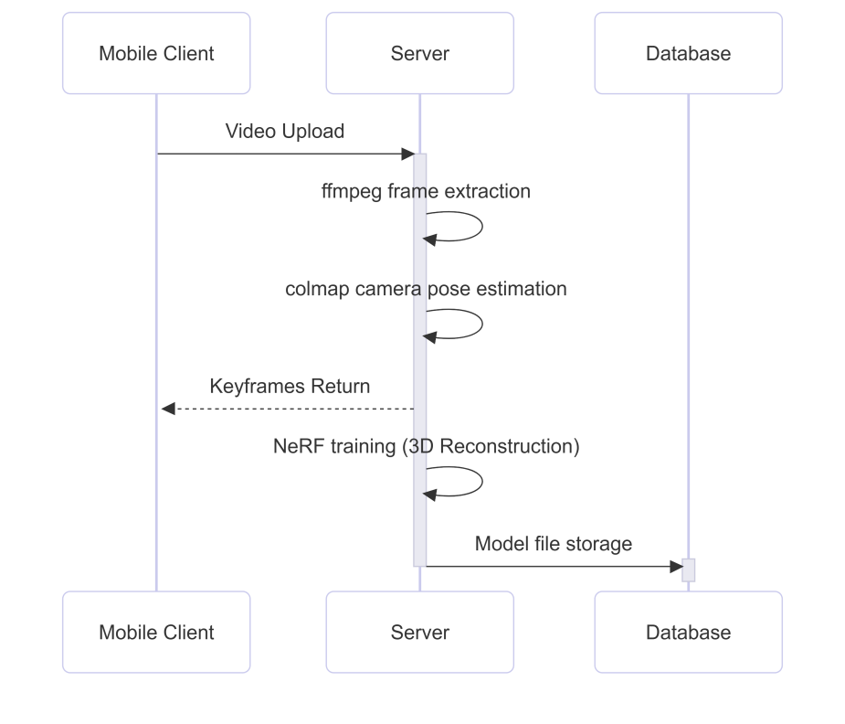

Fig1: NeRF-based Video 3D Reconstruction Sequence Diagram

* 3D Modeling Interaction

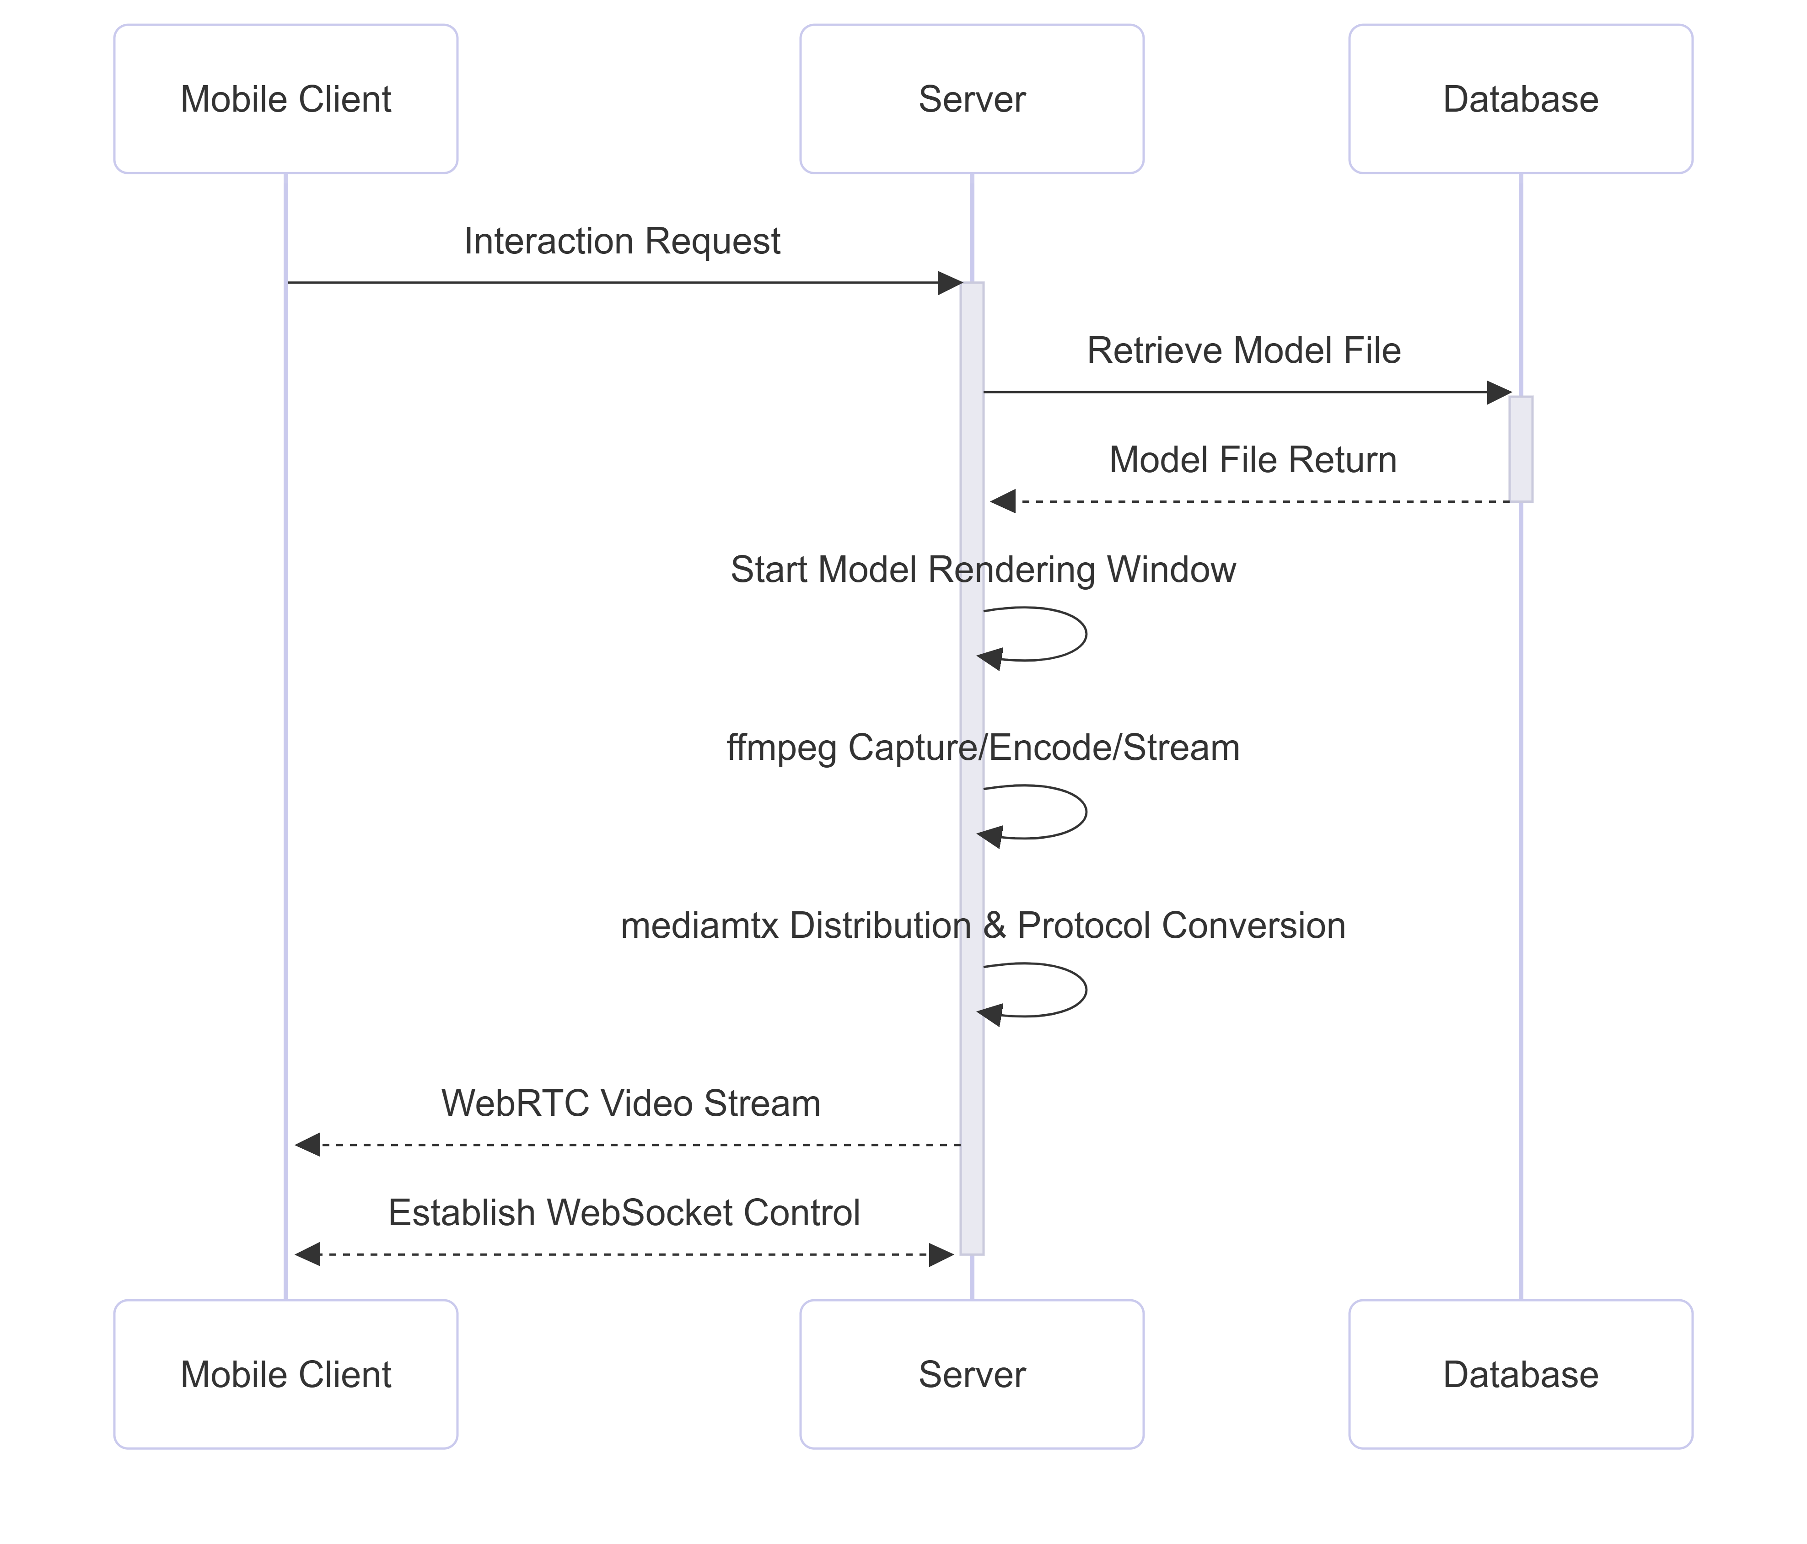

Fig2: Cloud-Based 3D Rendering & Real-Time Interaction Sequence

* Model Export and Sharing

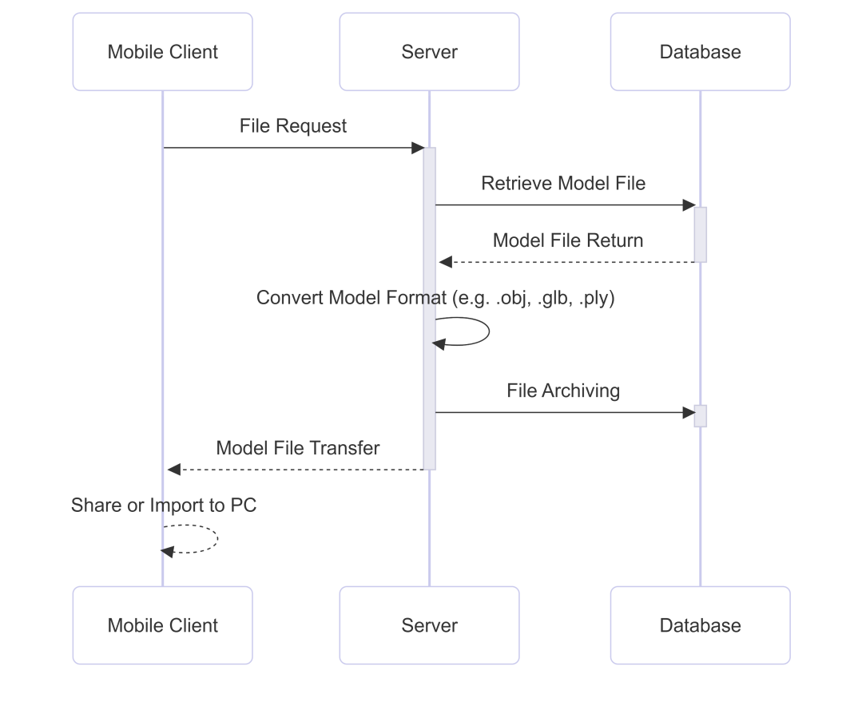

Fig3: 3D Model Export & Format Conversion Workflow

**1.1.3 Platform Positioning**  
Δ3D is a cutting-edge 3D modeling tool specifically developed for Android mobile devices, positioning itself as an easy-to-use and cost-effective solution for professionals and enthusiasts alike. It is particularly suitable for users who need to create high-quality 3D models quickly and efficiently, without the complexity or expense associated with traditional 3D modeling tools. Δ3D is ideal for a wide range of users, from e-commerce sellers who need to create product models for virtual stores, to content creators looking to enhance their videos with realistic 3D models, and professionals such as architects and designers who require quick prototyping or design visualization. The app not only allows users to create, edit, and preview 3D models on their smartphones but also supports sharing and exporting to various platforms, thus opening up new possibilities for collaboration and creativity. Through its user-friendly interface and cloud processing capabilities, Δ3D brings the power of professional 3D modeling to anyone with a mobile device.

**1.2 Product Features**

**1.2.1 Real-time Camera 3D Scanning Functionality**  
Δ3D offers real-time 3D scanning functionality using the smartphone’s camera, allowing users to instantly capture objects and convert them into 3D models. By simply moving the camera around the object, users can generate a comprehensive 3D representation. The app’s real-time scanning feature ensures that every angle is captured accurately, while built-in algorithms automatically process the data to create a 3D model on the fly. This functionality empowers users to create 3D models with ease, without requiring any specialized hardware or software. It’s designed to be intuitive, making it suitable for both beginners and professionals in need of quick 3D content creation.

**1.2.2 Interactive 3D Model Editing and Preview**  
Once the 3D model is created, users can interactively preview and edit the model within the app. The app provides a rich set of editing tools that allow users to rotate, zoom in/out, and switch between different viewing angles to examine the model from all perspectives. Additionally, users can make adjustments to the model, including changing textures, scaling, or modifying the mesh. This interactive preview and editing feature ensures that users can refine their models to meet their exact specifications before finalizing them. Whether for product design, content creation, or professional projects, this feature provides flexibility and control over the modeling process, all within the mobile app environment.

**1.2.3 Model Export and Sharing Capabilities**  
Δ3D makes it simple to export the final 3D models into various widely-used file formats, such as .obj, .glb, and .ply. This allows users to seamlessly integrate the models into other design tools, applications, or virtual environments. For example, users can export their models to their computers for further editing or incorporate them into game development, 3D animations, or virtual reality (VR) applications. Additionally, the app supports direct sharing of 3D models to social media platforms, cloud storage, or 3D model communities, enabling users to showcase their creations and collaborate with others. The ability to share 3D models easily broadens the use cases for the app, from marketing and e-commerce to educational and creative projects.

**1.2.4 Cloud Storage and Synchronization Features**  
Δ3D integrates cloud storage functionality, ensuring that all user-generated 3D models are securely saved and synchronized across devices. This cloud-based system allows users to access their models from any device with the app installed, providing seamless continuity of work. Whether users switch from one mobile device to another or want to back up their models, the cloud storage feature ensures that their data is protected and always available. Moreover, users can sync their models and associated data, such as preferences and settings, across multiple devices, enhancing the flexibility and accessibility of their work. The cloud synchronization feature ensures that users’ 3D models are readily available for sharing, editing, or exporting at any time.

**1.3 Technical Architecture**

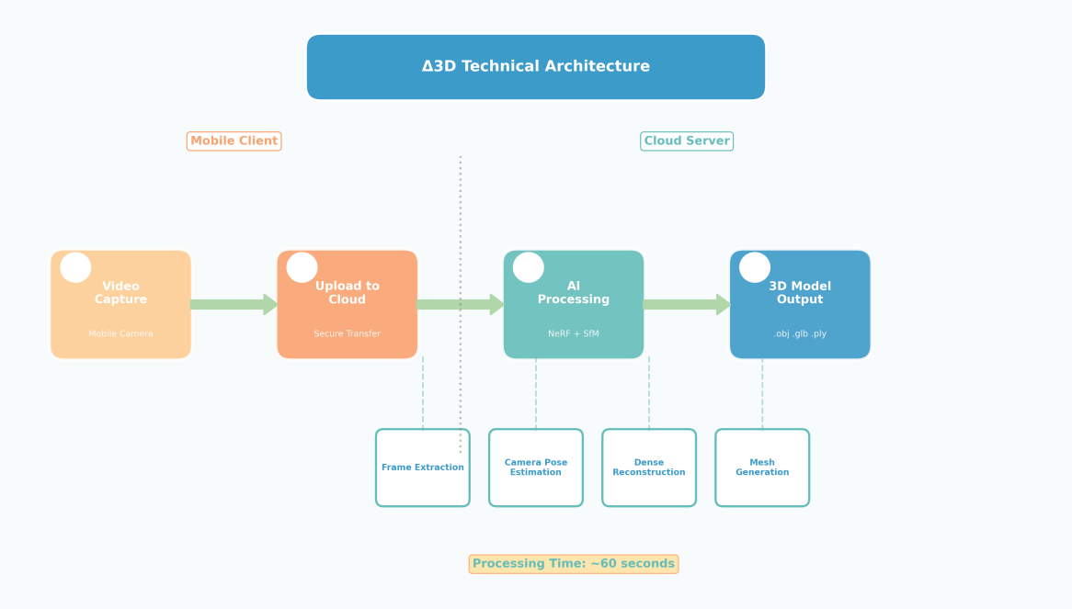

Fig4: Delta3D Technical Architecture Diagram

**1.3.1 3D Reconstruction Algorithm Technology Stack**  
The core of Δ3D’s functionality lies in its advanced 3D reconstruction algorithm stack, which enables users to convert real-world objects into accurate digital 3D models using their mobile devices[2]. The app employs a combination of state-of-the-art computer vision techniques, such as structure-from-motion (SfM), simultaneous localization and mapping (SLAM), and photogrammetry[7]. These algorithms allow the app to capture and analyze multiple images taken from different angles, estimating the object’s 3D geometry with precision.

Once the initial data is gathered, the algorithm employs dense point cloud reconstruction, creating a highly detailed and accurate model by refining the point cloud data and converting it into a mesh. The technology stack also includes mesh optimization and texture mapping techniques, which improve the visual quality and realism of the 3D models, even on mobile devices. The algorithms are designed to work in real time, providing users with immediate feedback as they capture the object, and are optimized for the processing power of mobile devices, making high-quality 3D modeling accessible to everyone.

**1.3.2 Mobile Performance Optimization Solutions**  
Given that 3D reconstruction and processing can be resource-intensive, Δ3D is designed with mobile performance optimization in mind. To ensure smooth operation on a wide range of mobile devices, the app utilizes several key optimization techniques. These include efficient memory management, parallel processing, and GPU acceleration, which leverage the processing power of modern smartphones to handle complex computations without draining battery life or slowing down the device[10].

Additionally, the app is optimized for different levels of device performance, automatically adjusting the complexity of the 3D reconstruction process based on the user’s device specifications. The use of cloud-based processing also helps to offload some of the heavy computational tasks from the device, further enhancing performance. This ensures that users can create high-quality 3D models even on mid-range or lower-end smartphones, without compromising on the app’s functionality.

To improve user experience, Δ3D features adaptive algorithms that dynamically adjust the image resolution and processing power depending on the current usage context, such as the complexity of the model being scanned or the available device resources. This approach ensures that the app remains responsive while delivering excellent results across different devices.

**1.3.3 User Interface Design Philosophy**  
The user interface (UI) of Δ3D is designed with a focus on simplicity, intuitiveness, and accessibility. Understanding that 3D modeling can often seem complex and intimidating, the app’s UI aims to make the process as straightforward as possible for users of all skill levels. The interface is clean, with a minimalistic design that emphasizes functionality without overwhelming the user.

The app uses clear, visual cues to guide users through the scanning, editing, and exporting process. Interactive tutorials and on-screen instructions provide users with step-by-step guidance, ensuring that even first-time users can quickly get started. The UI is also designed to be responsive, with large buttons and touch-friendly controls that allow users to perform tasks with ease.

Furthermore, the app’s UI supports multi-touch gestures for interacting with 3D models, such as pinch-to-zoom, drag to rotate, and swipe to pan. These features allow users to engage with their models in a natural, intuitive way, making it easier to explore and refine their creations.

The design philosophy extends to the app’s performance, ensuring that it runs smoothly even on devices with varying screen sizes and resolutions. Whether on a tablet or a smartphone, the interface adapts to different screen sizes, providing a consistent and seamless user experience.

**2. Unique Selling Proposition**

**2.1 Core Competitive Advantages**

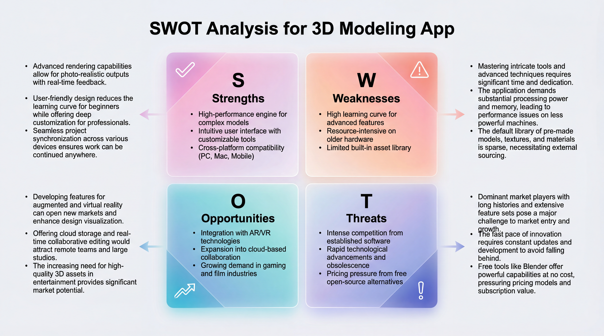

Fig5: SWOT Analysis Diagram

**2.1.1 Technological Breakthrough in Mobile Real-time 3D Modeling**  
One of the most significant competitive advantages of Δ3D is its technological breakthrough in mobile real-time 3D modeling. Unlike traditional 3D modeling tools, which require specialized hardware such as high-end 3D scanners or expensive workstations, Δ3D enables users to create accurate 3D models directly from their smartphones in real time. The app leverages advanced algorithms like structure-from-motion (SfM) and photogrammetry to process image data captured by the smartphone’s camera, transforming it into high-quality 3D models. This breakthrough makes 3D modeling not only more accessible but also faster and more efficient, allowing users to generate 3D models in minutes rather than hours. This unique feature sets Δ3D apart from other mobile apps in the market, positioning it as a cutting-edge solution for both casual users and professionals looking for quick and precise 3D content creation on the go.

**2.1.2 Accessibility Without Professional Equipment Requirements**  
Δ3D’s accessibility is another key advantage. While traditional 3D modeling and scanning tools often require expensive professional equipment (such as 3D scanners, specialized cameras, or high-performance computers), Δ3D democratizes 3D modeling by enabling users to leverage the capabilities of their smartphones. With just a phone camera, users can capture and create detailed 3D models, eliminating the need for costly equipment and technical expertise. This makes it especially appealing for individuals or small businesses in industries such as e-commerce, content creation, architecture, and design, who may not have the budget or resources to invest in high-end 3D scanning equipment. The app's affordability and ease of use make it a valuable tool for a wide range of users, from hobbyists to professionals.

**2.1.3 Balance Between High-Precision Modeling and User-Friendly Operation**  
Δ3D strikes a perfect balance between high-precision modeling and a user-friendly interface. While many 3D modeling tools can be intimidating and require extensive training, Δ3D is designed to be intuitive and accessible for users with varying levels of experience. The app provides powerful features for capturing, editing, and exporting 3D models, all while maintaining ease of use. Users can quickly capture objects, preview the 3D models in interactive environments, and make adjustments using simple controls, without needing any specialized knowledge in 3D design or modeling.

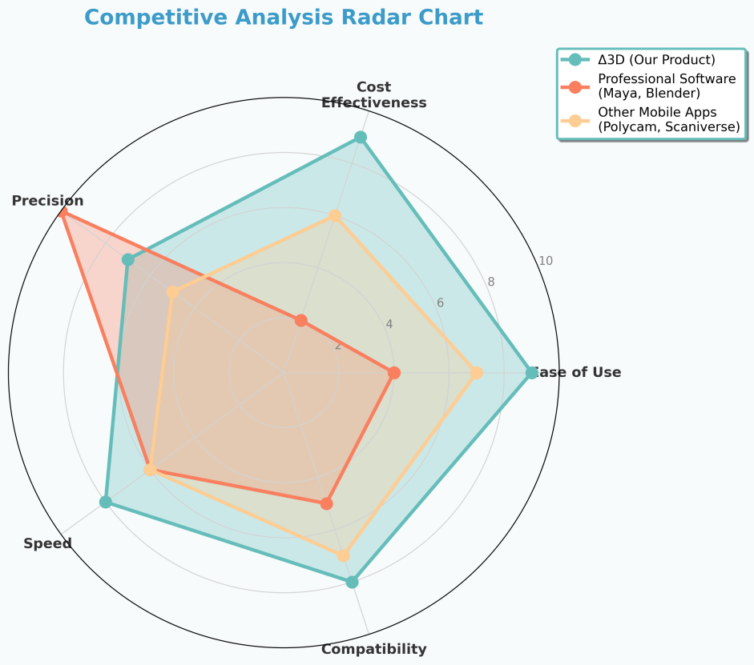

Fig6: Delta3D Competitive Analysis Radar Chart)

At the same time, Δ3D doesn’t compromise on the precision of its models. The app uses advanced 3D reconstruction algorithms and real-time processing to ensure that the generated models are of high quality, suitable for professional applications such as product visualization, architectural design, and virtual reality. Whether users need quick prototypes or highly detailed models, Δ3D offers both the accuracy and the usability that modern creators demand.

**2.2 Differentiation Strategy**

**2.2.1 Differentiation from Professional 3D Software**  
Δ3D distinguishes itself from traditional professional 3D software by focusing on accessibility, ease of use, and mobile-centric design without sacrificing the quality of the final output. While professional 3D software like Autodesk Maya, Blender, or ZBrush offers comprehensive, high-end features for expert users, these tools are typically complex, require significant learning curves, and are hardware-intensive. Δ3D, on the other hand, simplifies the 3D modeling process to make it accessible to a wider audience, from beginners to professionals looking for quick and efficient 3D model creation on the go.

Unlike professional desktop software, which may require powerful workstations and a deep understanding of 3D modeling principles, Δ3D allows users to create high-quality models directly on their mobile devices. The app eliminates the need for advanced training and the hardware cost associated with professional software, making it an ideal solution for users who require quick, precise 3D models but lack the resources or time to use traditional tools. Δ3D strikes a balance by providing a simplified, streamlined experience while still delivering professional-grade results for practical uses such as e-commerce, content creation, architecture, and design.

**2.2.2 Technical Advantages Over Existing Mobile 3D Applications**  
When compared to other mobile 3D applications, Δ3D stands out due to its cutting-edge 3D reconstruction algorithms and real-time processing capabilities. While many existing mobile apps offer basic 3D scanning and modeling functions, they often struggle with accuracy, processing speed, and model quality. Δ3D overcomes these challenges by using advanced computer vision technologies, such as structure-from-motion (SfM) and photogrammetry, to ensure that the generated 3D models are both accurate and detailed.

Furthermore, Δ3D takes advantage of mobile device capabilities, including GPU acceleration and cloud-based processing, to offer real-time model generation. This allows users to see the results almost immediately, reducing the time needed for post-processing or corrections. Additionally, Δ3D offers more comprehensive model editing features than many competing mobile apps, including texture mapping, mesh refinement, and interactive editing tools. The ability to seamlessly export models in multiple formats (.obj, .glb, .ply) and share them directly to social media or cloud platforms further sets it apart from other mobile 3D apps, which may have limited export options.

**2.2.3 Cost-Effectiveness Advantage Analysis**  
Δ3D’s cost-effectiveness is another key differentiator in the market. Traditional 3D modeling tools often require significant financial investment in both software licenses and specialized hardware. Professional 3D scanners and modeling workstations can cost thousands of dollars, making them prohibitive for many small businesses and independent creators. On the other hand, Δ3D operates entirely on mobile devices, allowing users to leverage the power of their existing smartphones without the need for expensive equipment. The app itself offers a freemium model, with affordable subscription options for advanced features, making it a low-cost solution for users who need high-quality 3D models but do not have the budget for expensive software or hardware.

The app’s cloud-based processing also adds to its cost-effectiveness, as it reduces the need for heavy processing on the user’s device, ensuring that even users with less powerful smartphones can create detailed models. By providing a comprehensive and accessible solution at a fraction of the cost of traditional 3D tools, Δ3D offers a highly attractive alternative for industries like e-commerce, content creation, and design, where budget constraints are often a major consideration.

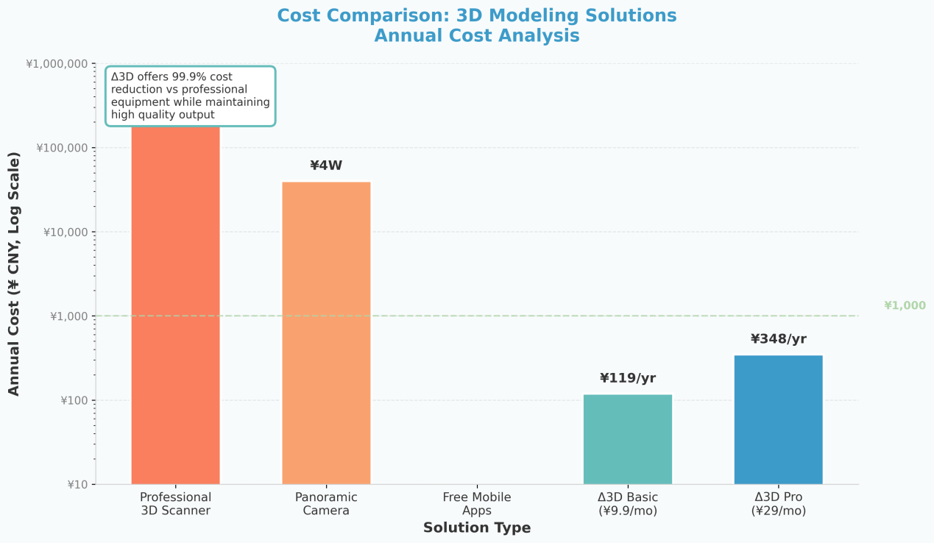

Fig7: Annual Cost Comparison: 3D Modeling Solutions

**2.3 Value Proposition**

**2.3.1 Providing Professional-Grade 3D Modeling Experience for Ordinary Users**  
Δ3D offers a professional-grade 3D modeling experience tailored for ordinary users, making high-quality 3D content creation accessible to a broader audience. Traditionally, 3D modeling has been reserved for experts who have access to expensive tools and specialized training. However, Δ3D breaks down these barriers by providing an easy-to-use, mobile solution that enables anyone—whether a beginner, hobbyist, or small business owner—to create detailed 3D models with just a smartphone. The app’s intuitive design, coupled with powerful real-time 3D reconstruction algorithms, ensures that users can produce professional-level models without the need for expensive equipment or extensive experience in 3D modeling. Whether for e-commerce product visualization, content creation, or prototyping, Δ3D empowers ordinary users to generate high-quality 3D models effortlessly.

**2.3.2 Lowering Barriers to 3D Content Creation**  
By offering a mobile solution for 3D modeling, Δ3D effectively lowers the barriers to entry for 3D content creation. Historically, 3D content creation has required specialized hardware, complex software, and advanced knowledge. Δ3D removes these obstacles by allowing users to create, edit, and export 3D models using only their smartphones. This democratization of 3D modeling opens up new opportunities for creators, including small businesses, independent artists, content creators, and even hobbyists who may have previously been deterred by the cost or complexity of traditional 3D tools. The app’s easy-to-follow workflows and real-time feedback make 3D modeling a hassle-free experience, making it accessible to anyone, regardless of their technical expertise. This accessibility fosters creativity, enabling users to bring their ideas to life in 3D without the need for expensive professional services or tools.

**2.3.3 Supporting AR/VR Content Ecosystem Development**  
As the demand for augmented reality (AR) and virtual reality (VR) experiences grows, Δ3D plays a pivotal role in supporting the development of the AR/VR content ecosystem. With the increasing adoption of AR/VR technologies across industries like entertainment, education, retail, and real estate, there is a rising need for high-quality 3D models to populate these immersive environments. Δ3D addresses this demand by providing users with the ability to easily create and export 3D models in formats compatible with AR and VR applications (.obj, .glb, .ply). This makes it easier for creators to produce 3D content for AR/VR platforms, helping to fuel the expansion of the AR/VR ecosystem. Whether for creating 3D assets for virtual tours, AR-enhanced shopping experiences, or VR gaming, Δ3D provides the tools to bridge the gap between 3D model creation and AR/VR application development. By empowering users to produce high-quality models quickly and easily, Δ3D contributes to the growth of the AR/VR content pipeline, enabling faster development and more engaging user experiences across these immersive platforms.

**3.1 Primary User Groups**

**3.1.1 Creative Designers: Rapid Prototyping Needs**Creative designers, including product designers, industrial designers, and graphic artists, often require quick prototyping and the ability to visualize ideas in 3D before moving to production. Δ3D provides these users with an efficient tool to bring their ideas to life rapidly[2]. With the ability to capture physical objects and turn them into 3D models in real time, designers can create prototypes quickly, experiment with different shapes and designs, and make adjustments on the fly. The app allows for seamless editing, scaling, and texturing of models, making it an invaluable tool for designers who need to iterate on their concepts quickly. Additionally, the mobile nature of the app enables designers to create and edit models on the go, enhancing their flexibility and workflow, especially in dynamic environments like design studios or client meetings.

**3.1.2 Educators: Teaching Demonstration and Interactive Requirements**  
For educators, especially those in fields like architecture, engineering, and industrial design, Δ3D serves as an interactive tool for teaching and demonstration. Traditional teaching methods often rely on flat images or physical models to convey complex 3D concepts, which can be limiting in terms of interactivity and depth. With Δ3D, educators can create detailed 3D models that students can interact with, rotate, and explore from different angles. This hands-on experience enhances learning by allowing students to visualize and engage with the subject matter in a dynamic way. Whether it’s for a 3D representation of historical artifacts, scientific models, or architectural designs, the app’s ability to create and share interactive 3D models transforms how concepts are taught and understood in the classroom.

**3.1.3 E-commerce Sellers: Product 3D Display Needs**  
E-commerce sellers, especially those in sectors such as fashion, electronics, and furniture, face a significant challenge in displaying their products effectively online. Traditional flat images or 2D videos can fail to fully showcase a product’s features and details, which can affect sales and customer satisfaction. With Δ3D, e-commerce sellers can create realistic 3D models of their products, allowing potential buyers to interact with the items virtually. Customers can view the product from different angles, zoom in for detailed views, and even see how it fits within a space using AR technology. This immersive 3D experience helps e-commerce sellers differentiate themselves from competitors and enhance the online shopping experience, ultimately driving higher engagement, reduced return rates, and increased sales.

**3.1.4 Individual Users: Memorabilia and Creative Sharing Demands**  
Individual users who are interested in preserving personal memories or sharing creative works can also benefit from Δ3D. Whether it’s creating 3D models of a special event, a favorite object, or a personal project, the app allows users to capture and recreate real-world items in digital form. These models can be shared with friends, family, or the broader community through social media or 3D model sharing platforms. Δ3D enables users to showcase their creativity and commemorate important moments in a new and innovative way, allowing for the creation of digital memorabilia. Additionally, the app fosters a creative outlet by enabling users to design and share their unique 3D models, contributing to a vibrant community of hobbyists and creators who can inspire and collaborate with each other.

**3.2 User Needs Analysis**

**3.2.1 Pain Point Identification: Complexity and Cost of Traditional 3D Modeling**  
One of the major pain points that users face in the realm of 3D modeling is the complexity and high cost associated with traditional 3D modeling tools. Professional 3D software often requires extensive training, high-end hardware, and expensive software licenses. For many small businesses, individual creators, and educators, these costs and complexities act as significant barriers to entry. Moreover, traditional 3D modeling tools can be time-consuming and require advanced technical skills to achieve the desired results.

For creative designers and educators, the need for quick prototyping and interactive teaching often conflicts with the steep learning curves and time-intensive processes required by professional 3D modeling tools. Similarly, e-commerce sellers struggle with the high cost of professional 3D scanning equipment and the difficulty of creating interactive, detailed product displays that engage customers. For individual users, capturing and creating 3D models of personal memories or creative works often requires expensive devices or professional assistance.

Δ3D addresses these pain points by providing an affordable, mobile-based solution that allows users to create high-quality 3D models easily and quickly, without the need for expensive equipment or advanced technical skills.

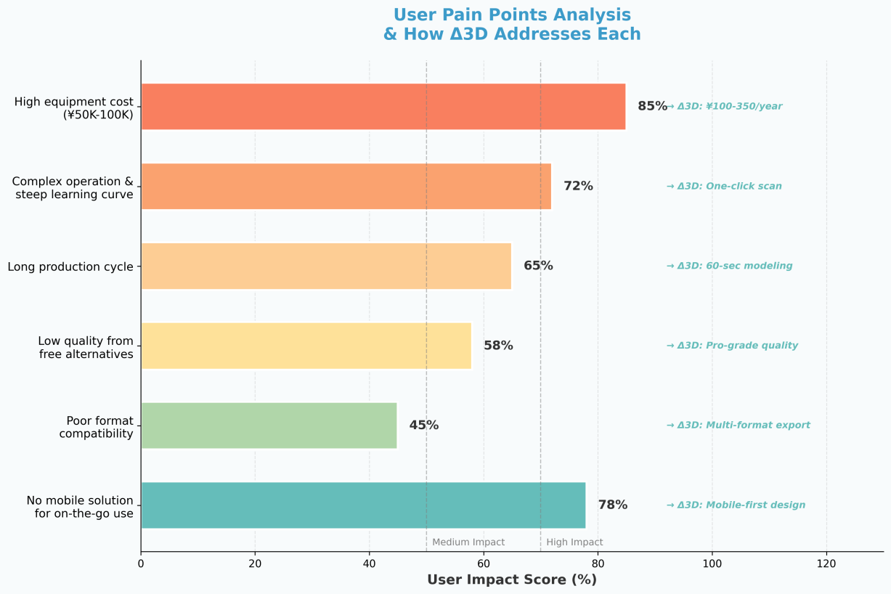

Fig8: User Pain Points Analysis & How Delta3D Addresses Each

**3.2.2 Use Cases: Design, Education, E-commerce, Entertainment**

* **Design**: For designers, Δ3D provides an invaluable tool for rapid prototyping. Whether it’s product design, interior design, or industrial design, the app allows designers to quickly capture and visualize objects in 3D, enabling them to iterate on designs more effectively. By using real-time scanning and model editing features, designers can experiment with shapes, textures, and scales without the need for complex software or physical prototypes.
* **Education**: Educators in fields such as architecture, engineering, and science can leverage Δ3D to enhance learning by creating interactive 3D models. Students can interact with these models in ways that 2D images or flat diagrams cannot match, gaining a deeper understanding of complex concepts. Whether it’s visualizing historical artifacts, exploring scientific phenomena, or creating models for architectural projects, the app’s simplicity and functionality transform the way content is presented and engaged with in the classroom.
* **E-commerce**: For e-commerce sellers, especially those in product-heavy industries like fashion, home décor, or electronics, the ability to provide a virtual shopping experience with interactive 3D models significantly enhances the customer experience. Δ3D enables sellers to create detailed, realistic 3D models of products, giving customers the ability to explore products from all angles and helping to increase buyer confidence, reduce return rates, and ultimately drive sales.
* **Entertainment**: In the entertainment industry, content creators and hobbyists can use Δ3D to create 3D models for animation, gaming, virtual reality (VR), and augmented reality (AR). The app enables rapid creation and sharing of 3D models, helping users visualize characters, environments, and assets for their creative projects. Whether it’s for a short film, game prototype, or AR experience, Δ3D offers an affordable and accessible tool for 3D content creation, allowing creators to bring their ideas to life without the need for costly software or equipment.

**3.2.3 User Behavior Patterns: Mobile-First, Instant Gratification Needs**  
In today’s fast-paced, mobile-driven world, users expect instant access and gratification. Δ3D’s mobile-first approach addresses this need by providing a user-friendly, on-the-go solution for 3D modeling. Most users prefer mobile solutions due to the convenience and portability of smartphones. With Δ3D, users can quickly capture and process 3D models without the need for desktop computers or specialized equipment[2]. This immediacy is particularly valuable for creative professionals, educators, and e-commerce sellers who require fast results and a smooth, seamless workflow.

Additionally, users are increasingly looking for applications that provide quick and easy results. Δ3D’s real-time processing allows users to see their 3D models as soon as they capture the object, fulfilling the growing demand for instant feedback and results. Whether it’s a designer who needs to quickly test an idea, an educator who wants to demonstrate a concept during a class, or an e-commerce seller who needs to create a 3D product display on the spot, Δ3D’s mobile-first, fast-response features cater to users’ instant gratification needs.

**3.3 User Acquisition Strategy**

**3.3.1 Early Seed User Cultivation**  
To establish a strong foundation and validate the app’s core features, early seed user cultivation will be a critical focus for Δ3D. These early adopters, including design professionals, educators, content creators, and e-commerce sellers, will provide valuable feedback on the app's usability, functionality, and overall user experience. By targeting specific user groups that have clear use cases for 3D modeling, we can ensure that the app’s features are aligned with user needs from the outset.

Seed users will be encouraged through personalized outreach, exclusive access to new features, and early-bird incentives such as free premium subscriptions for a limited period. These users will be part of a select group invited to test the app during its beta phase, enabling the team to gather detailed insights and make iterative improvements. The goal is to create a group of loyal users who are passionate about the app and can act as ambassadors in their respective communities.

**3.3.2 Community Building and Word-of-Mouth Marketing**  
Community building will be a core strategy for user acquisition, as it helps to create a sense of belonging among users and fosters organic growth through word-of-mouth marketing. Δ3D will focus on creating an active online community where users can share their 3D creations, discuss tips and tricks, and collaborate on projects. This community could be built on social media platforms (such as Instagram, Facebook, and Twitter), forums, and specialized 3D modeling groups.

Additionally, a robust in-app community feature will allow users to upload, showcase, and discuss their 3D models, further enhancing user engagement. Encouraging users to share their experiences on social media, with built-in sharing features such as easy export to Instagram, Twitter, and other platforms, will help spread awareness. By creating a culture of creativity, collaboration, and recognition within the community, Δ3D will naturally generate word-of-mouth marketing, where satisfied users recommend the app to their peers, colleagues, and followers.

To further boost word-of-mouth marketing, users could be incentivized to invite others through referral programs that reward both the referrer and the new user with free premium features or other perks. This organic, community-driven marketing approach will lead to an expanding user base, as users themselves help grow the app’s presence.

**3.3.3 Partner Referral Programs**  
Another key component of the user acquisition strategy will be partnering with relevant organizations, influencers, and other businesses that have an interest in 3D content creation. These partnerships will focus on offering referral programs, where both partners and their audiences benefit from using the app. For example, collaborating with e-commerce platforms, design schools, and content creation communities could help expose Δ3D to their existing user bases, providing a channel for acquisition that aligns with the app's target demographic.

Partner referral programs will include exclusive offers for partner audiences, such as discounts on premium plans, extended free trials, or access to unique features. In return, partners can receive commission-based rewards, brand visibility, or enhanced collaboration opportunities. Influencers and thought leaders within the 3D modeling, design, and e-commerce sectors could also play a crucial role in this strategy by showcasing how they use Δ3D in their own work, driving their followers to try out the app for themselves.

By collaborating with like-minded organizations and individuals, Δ3D can quickly tap into existing, highly engaged user bases and accelerate growth through referrals. This strategy helps to create a sustainable pipeline for new users, while ensuring that the app remains top-of-mind in key industries.

**4.1 Market Size and Trends**

**4.1.1 Global 3D Modeling Software Market Size**  
The global 3D modeling software market is experiencing rapid growth, driven by the increasing demand for digital models in industries such as architecture, product design, entertainment, and manufacturing. In 2024, the market is expected to reach a value of several billion dollars, with projections suggesting that it will continue to expand in the coming years. The rise of cloud technologies, AI integration, and powerful computational tools has significantly contributed to the accessibility and efficiency of 3D modeling software. By 2030, the market size is expected to reach nearly $40 billion, with a compound annual growth rate (CAGR) of over 10%.

In addition, the ongoing trend of digital transformation in industries is driving the demand for more advanced, user-friendly, and affordable 3D modeling solutions. As businesses and professionals across various sectors increasingly adopt 3D modeling for design, visualization, and prototyping, the market for these tools continues to expand. The availability of software on cloud platforms has further democratized access to 3D modeling, allowing smaller companies and individual creators to leverage these tools without the need for expensive hardware.

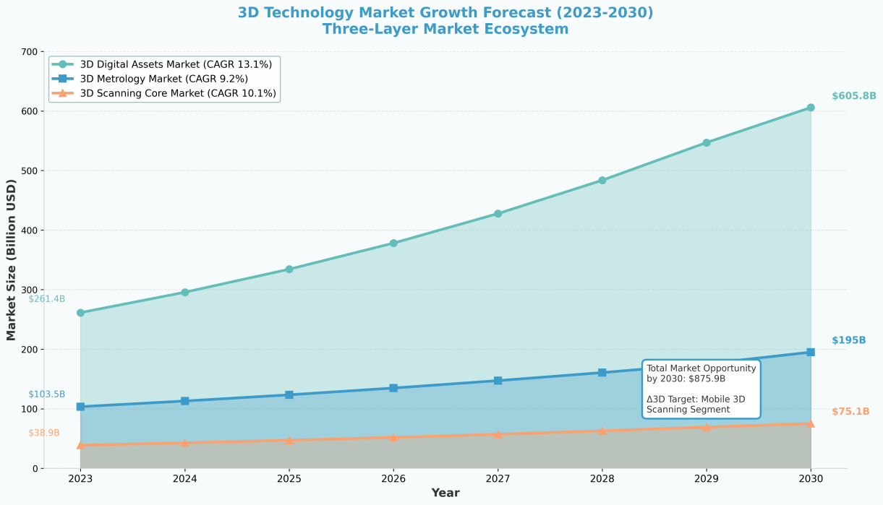

Fig9: 3D Technology Market Growth Forecast: 2023-2030

**4.1.2 Mobile AR/VR Application Market Growth Trends**  
The mobile AR/VR market is another rapidly growing sector that is driving demand for 3D content. The global mobile AR/VR application market is expected to grow at a CAGR of approximately 18% from 2024 to 2030. By 2030, the market is projected to be worth over $150 billion, primarily due to the increasing adoption of immersive technologies in various industries, including gaming, entertainment, education, and retail[3]. As AR/VR technologies continue to evolve, they are becoming more accessible to mobile users, driving further growth in demand for 3D models that can be integrated into these environments .

In particular, mobile AR applications, powered by advanced smartphones and improved internet connectivity (e.g., 5G), are expected to lead the market. The ability to create and interact with 3D models in real-time through mobile AR apps is revolutionizing how users experience content, from interactive gaming to virtual shopping experiences. As mobile AR/VR applications become mainstream, the need for high-quality 3D modeling tools is expected to rise, creating new opportunities for tools like Δ3D to capture this expanding market.

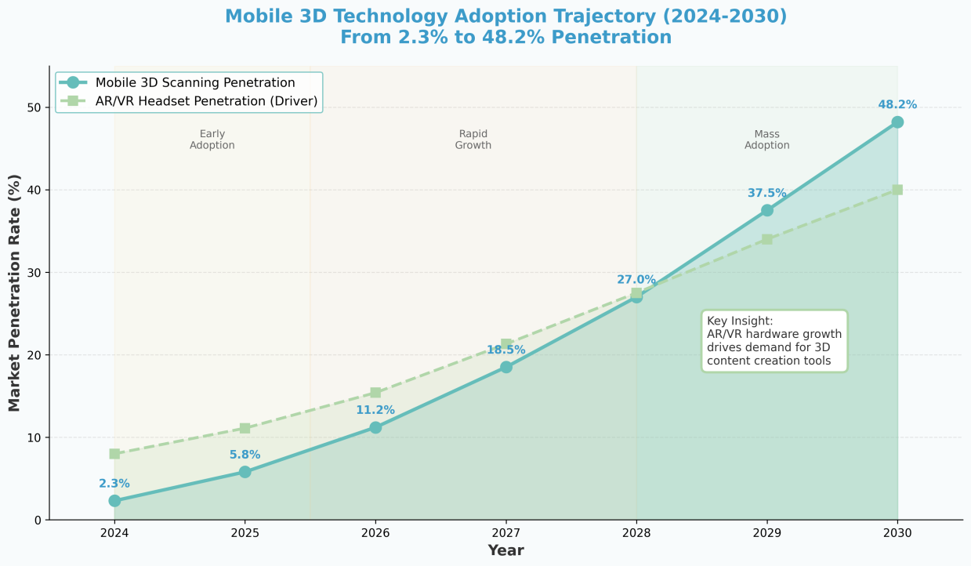

Fig10: Mobile 3D Technology Adoption Trajectory: 2024-2030

**4.1.3 Current State of 3D Applications in China’s Android Market**  
China represents one of the largest and most rapidly growing markets for mobile applications, including 3D modeling and AR/VR tools. The Android ecosystem in China is particularly large, with millions of active users across a wide variety of applications[6]. The 3D modeling application market on Android is growing steadily, as businesses and individual users increasingly seek mobile solutions to create and share 3D content. In 2024, the Chinese market for mobile 3D applications is expected to grow by more than 15%, driven by increasing demand in industries such as e-commerce, gaming, and education[3].

E-commerce platforms are particularly prominent in the use of 3D applications, as retailers look for ways to provide immersive product experiences to online shoppers. 3D modeling tools are enabling better product visualization and augmented reality (AR) experiences for consumers, significantly enhancing online shopping experiences. Additionally, educational institutions and content creators in China are increasingly adopting 3D technologies for teaching, creative work, and interactive media production.

The AR/VR market in China is also seeing a surge, with mobile AR applications becoming more integrated into various sectors, including retail, entertainment, and education. This trend is creating a strong demand for mobile-friendly 3D content creation tools that can feed into AR/VR applications, further propelling the growth of 3D modeling apps like Δ3D[4].

**4.2 Competitive Landscape Analysis**

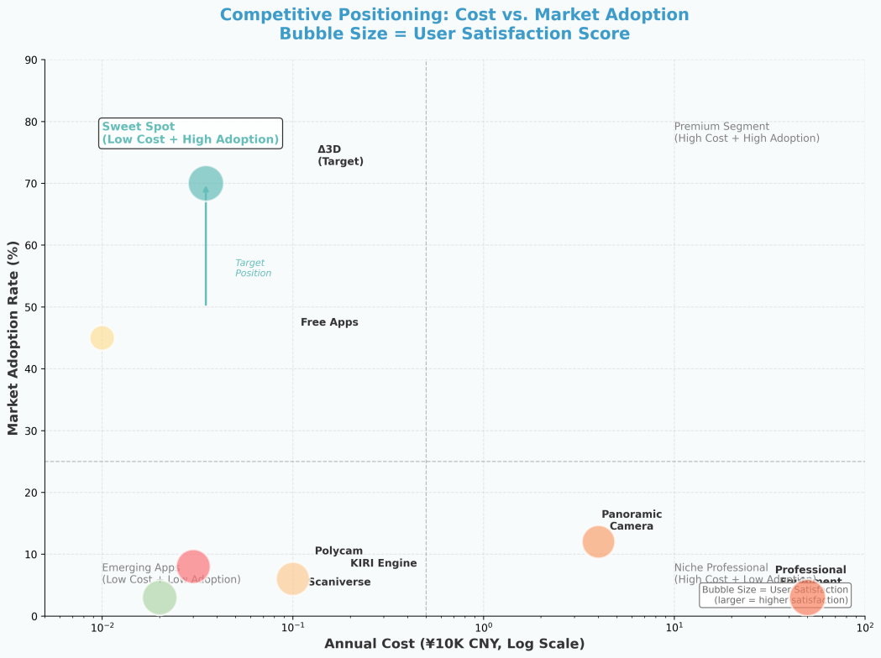

Fig11: Competitive Positioning: Cost vs. Market Adoption

**4.2.1 Direct Competitor Analysis (Existing 3D Scanning Apps)**  
The direct competitors of Δ3D are existing mobile 3D scanning apps, which allow users to capture objects and create 3D models using smartphones. Key competitors include Polycam, Scaniverse, and KIRI Engine[5].

Polycam is one of the leading apps in the market, known for its high-quality scans using LiDAR and standard camera-based scanning. It provides detailed texture mapping and mesh refinement, but its dependency on LiDAR technology limits accessibility to users with older devices or non-iOS platforms. Additionally, Polycam’s subscription model for advanced features may discourage casual users due to its pricing.

Scaniverse, on the other hand, is recognized for its ease of use and ability to produce quick 3D models. It supports both iOS and Android, offering real-time preview and editing features. However, its editing tools are somewhat limited in the free version, with advanced functionalities locked behind a paywall, which could limit its appeal to budget-conscious users.

KIRI Engine is designed to be user-friendly and focuses on automatic 3D reconstruction using AI. While it offers detailed models for AR/VR applications, KIRI Engine also requires an internet connection for processing, which may hinder its usability in areas with poor connectivity or for users who prefer offline solutions.

**4.2.2 Indirect Competitor Analysis (Professional 3D Software, Online Tools)**  
Δ3D also faces competition from traditional professional 3D modeling software and online tools. Tools like Autodesk Maya and Blender dominate the high-end 3D modeling industry, offering a full suite of features for professionals in fields such as animation, game design, and visual effects. However, these tools come with significant drawbacks for casual users or businesses seeking a quick solution. Maya is expensive, with high licensing costs, and Blender, while free, has a steep learning curve, making it less accessible for non-experts. Additionally, neither is optimized for mobile devices, which limits their usability for on-the-go creators.

In contrast, online tools like Tinkercad provide an easier entry point for hobbyists and educators but lack advanced scanning capabilities and real-time processing features. While they are suitable for basic design work and learning, they do not compete directly with mobile-based scanning tools like Δ3D, which offer real-time 3D modeling and quick feedback, making it more accessible and practical for casual users and small businesses.

**4.2.3 Competitive Advantage and Disadvantage Comparison**  
Δ3D’s primary competitive advantage lies in its mobile-first design and ease of use. Unlike professional desktop software, Δ3D is optimized for smartphones, making it accessible to a broad user base without requiring high-end hardware. Its real-time 3D scanning, interactive model editing, and cloud processing make it an ideal solution for businesses and individuals who need quick, high-quality 3D models without the complexity and cost of traditional 3D modeling tools.

However, the trade-off for this accessibility is the level of complexity. While professional tools like Maya and Blender offer in-depth modeling, animation, and rendering capabilities, Δ3D is focused on providing a streamlined, easy-to-use experience for users who do not require such advanced features. Additionally, competitors like Polycam and Scaniverse have established themselves as leaders in the 3D scanning space, and their more advanced scanning capabilities may appeal to professionals or those with access to higher-end hardware, such as LiDAR-enabled devices.

**4.3 Market Opportunity Identification**

**4.3.1 New Opportunities Brought by Technological Developments**  
Recent advancements in mobile technology, particularly the rise of 5G networks and improved smartphone hardware (e.g., better cameras, increased processing power, and LiDAR sensors), present significant opportunities for Δ3D. These developments enable faster, more accurate 3D scanning, enhancing user experience and expanding the potential for real-time 3D modeling. Additionally, the growing availability of cloud computing has made it easier to offload complex processing tasks from the device to powerful cloud servers, thus enabling even entry-level smartphones to create high-quality 3D models. The ongoing evolution of AR/VR technologies also presents an opportunity for Δ3D to integrate its 3D models into immersive environments, further expanding its potential use cases in fields like gaming, virtual tourism, e-commerce, and education.

As mobile AR/VR adoption increases, the demand for 3D content that can seamlessly integrate into these platforms will continue to grow. This technological shift opens up new possibilities for content creation, providing Δ3D with the chance to position itself as an essential tool in the AR/VR ecosystem. Additionally, AI-driven features, such as automatic scene recognition, texture enhancement, and model optimization, could further elevate the app’s capabilities, making 3D modeling even more accessible and automated for users.

**4.3.2 Unmet User Demand Areas**  
Despite the rapid growth in 3D modeling tools, there are several unmet user demands that Δ3D can address. One key area is the demand for affordable, high-quality 3D modeling tools for small businesses and individual creators, particularly in sectors like e-commerce, content creation, and design. Many small businesses are currently unable to afford expensive professional software or the high upfront costs of 3D scanners. Δ3D's mobile-based solution fills this gap by providing an easy-to-use, cost-effective alternative that allows users to create professional-grade 3D models with just a smartphone.

Another unmet demand exists in simplifying the 3D modeling process for non-technical users. While traditional 3D modeling tools are complex and require specialized knowledge, there is a growing need for intuitive tools that allow users from various industries, such as education and entertainment, to create 3D content without the steep learning curve. Δ3D's user-friendly interface and real-time processing features can cater to these users, offering a seamless experience that doesn’t compromise on quality.

Additionally, the growing interest in personalized 3D content creation in sectors like retail (e.g., product visualization), real estate (e.g., virtual property tours), and education (e.g., interactive learning materials) represents a significant opportunity. By meeting the specific needs of these industries, Δ3D can tap into markets where the demand for 3D content creation is increasing but the tools available are either too expensive or too complex for widespread adoption.

**4.3.3 Potential Partnership and Ecosystem Opportunities**  
There are numerous partnership and ecosystem opportunities that can drive the growth of Δ3D. One such opportunity lies in partnering with e-commerce platforms, especially in the fashion, furniture, and electronics sectors. By integrating Δ3D’s technology into these platforms, sellers could create 3D models of their products, allowing customers to interact with them in a virtual space. This partnership could reduce product return rates and increase customer satisfaction by providing a more immersive shopping experience.

In the AR/VR sector, partnerships with AR/VR content developers could allow Δ3D to create 3D models that can be seamlessly integrated into virtual and augmented reality applications. As AR and VR continue to gain traction in industries like gaming, real estate, and education, the demand for 3D content will increase, and Δ3D’s role as a 3D model creation tool for these platforms could become critical.

Collaboration with educational institutions is another potential opportunity. With increasing interest in immersive learning and interactive educational content, Δ3D could partner with schools, universities, and e-learning platforms to create educational resources in the form of 3D models. This partnership could provide teachers and students with tools to visualize complex concepts, enhancing the learning experience and fostering engagement.

Lastly, strategic partnerships with cloud service providers could enhance the scalability and performance of Δ3D’s services, particularly in handling large 3D models and processing them efficiently. By leveraging cloud infrastructure, Δ3D could ensure that users have access to high-performance processing and storage, further enhancing the app’s capabilities.

**4.4 Market Entry Strategy**

**4.4.1 Segment Market Priority Ranking**  
To maximize the success of Δ3D, the market entry strategy must prioritize key segments that align with the app’s strengths in mobile 3D scanning and modeling. The following market segments are ranked based on their potential for growth, immediate need, and the app's ability to deliver value:

1. **E-commerce Sellers**  
   The e-commerce sector, particularly in fashion, electronics, and home goods, represents the most immediate and lucrative opportunity. The need for high-quality 3D product visualizations is growing, as online retailers seek to enhance the customer shopping experience through interactive and immersive product displays. By offering a mobile solution that allows sellers to create and share 3D models of their products, Δ3D can address pain points such as product returns and customer uncertainty. This segment has a high adoption potential given the ease of use and cost-effectiveness of the app for small to medium-sized businesses.
2. **Creative Designers**  
   Designers in fields such as industrial design, product design, and architecture are increasingly turning to 3D modeling tools for rapid prototyping and visualization. Δ3D’s mobile-based, real-time scanning features provide a unique advantage, allowing designers to quickly capture physical objects and translate them into digital models. This segment values fast, efficient, and cost-effective tools, making it a strong target for Δ3D’s growth.
3. **Educational Institutions**  
   With the rise of interactive learning and digital education, there is a growing demand for tools that enable educators and students to visualize and create 3D models. Δ3D can tap into this market by offering an easy-to-use platform for creating educational resources, such as interactive models of historical artifacts, scientific phenomena, and architectural structures. Educational institutions, both at the K-12 and university levels, represent a promising segment for adoption, especially as digital learning tools become more integrated into curriculums.
4. **Individual Users (Creative Sharing & Memorabilia)**  
   While this segment has broad appeal, the potential for high-volume revenue generation is lower compared to e-commerce and professional markets. However, as the app gains traction, individual users looking to create personalized 3D models for memorabilia or creative sharing represent a strong long-term opportunity. User-generated content can also foster a robust online community, increasing engagement and brand loyalty.

**4.4.2 Geographic Expansion Plan**  
Δ3D’s geographic expansion should be phased, starting with markets where the adoption of mobile technology and 3D content creation tools is growing rapidly[4]. The initial focus should be on[6]:

1. **China**  
   As the largest mobile market in the world, China presents an excellent opportunity for rapid adoption. With the increasing use of smartphones for e-commerce, entertainment, and education, there is a significant demand for accessible 3D modeling tools. By leveraging partnerships with local e-commerce platforms and educational institutions, Δ3D can quickly build a strong user base in this market. Additionally, China’s growing AR/VR industry offers an exciting opportunity for integration and collaboration.
2. **United States**  
   The U.S. is a key market for both e-commerce and creative industries. The country’s vast e-commerce landscape, particularly in sectors such as fashion and home goods, aligns with Δ3D’s strengths in providing product visualizations for online retailers. Furthermore, the U.S. has a strong presence of design professionals and educational institutions that can benefit from the app’s 3D modeling capabilities. Targeting both small businesses and larger enterprises in these industries will ensure broad market penetration.
3. **European Union**  
   Europe has a rapidly growing e-commerce sector, particularly in countries like Germany, the UK, and France, where the demand for high-quality product visualization is on the rise. The app can also find traction in educational institutions across the region, especially in STEM-focused programs where 3D models are increasingly used for teaching complex concepts. Additionally, the EU’s emphasis on digital innovation and creative industries presents a fertile ground for adoption.
4. **Emerging Markets**  
   As mobile technology continues to penetrate emerging markets in regions like Southeast Asia, Africa, and Latin America, there is a growing opportunity for mobile-based 3D solutions. While these regions may have lower purchasing power, the widespread use of smartphones and the growing interest in e-commerce and digital content creation make them viable markets for Δ3D’s expansion in the long term.

**4.4.3 Timing Selection and Risk Assessment**  
The timing of the market entry is critical for ensuring that Δ3D capitalizes on the growing demand for mobile 3D content creation tools. The following considerations should guide the timing strategy:

1. **Early Adoption Phase**: In the first 12-18 months, the focus should be on cultivating early adopters within targeted industries (e-commerce, design, education). By offering free trials and engaging early users, Δ3D can gather valuable feedback to improve the app and refine its value proposition. This phase will help build a strong user base and create initial traction.
2. **Growth Phase**: After successfully engaging early adopters, the next 12-24 months should focus on scaling user acquisition through paid advertising, partnerships, and influencer marketing. As the app gains recognition in the U.S., China, and Europe, this phase will emphasize expanding the user base, increasing market share, and entering new geographic regions.
3. **Maturity Phase**: Beyond 3-5 years, Δ3D should focus on enhancing its product offerings with new features, including integration with AR/VR platforms and more advanced AI-driven tools. This phase will focus on maintaining market leadership and increasing revenue through paid subscription models, B2B partnerships, and continued geographic expansion.

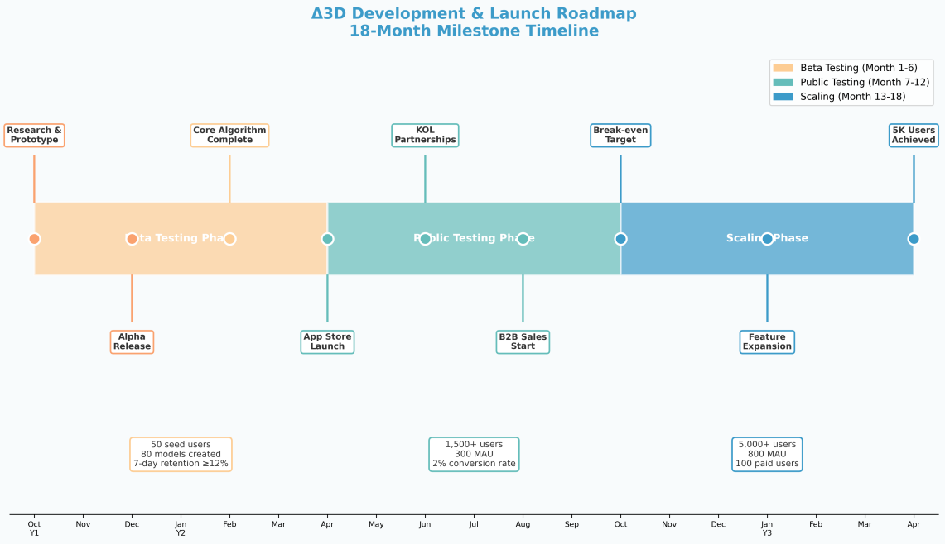

Fig12: Delta3D Development & Launch Roadmap: 18-Month Milestone Timeline

**5. Marketing Channels**

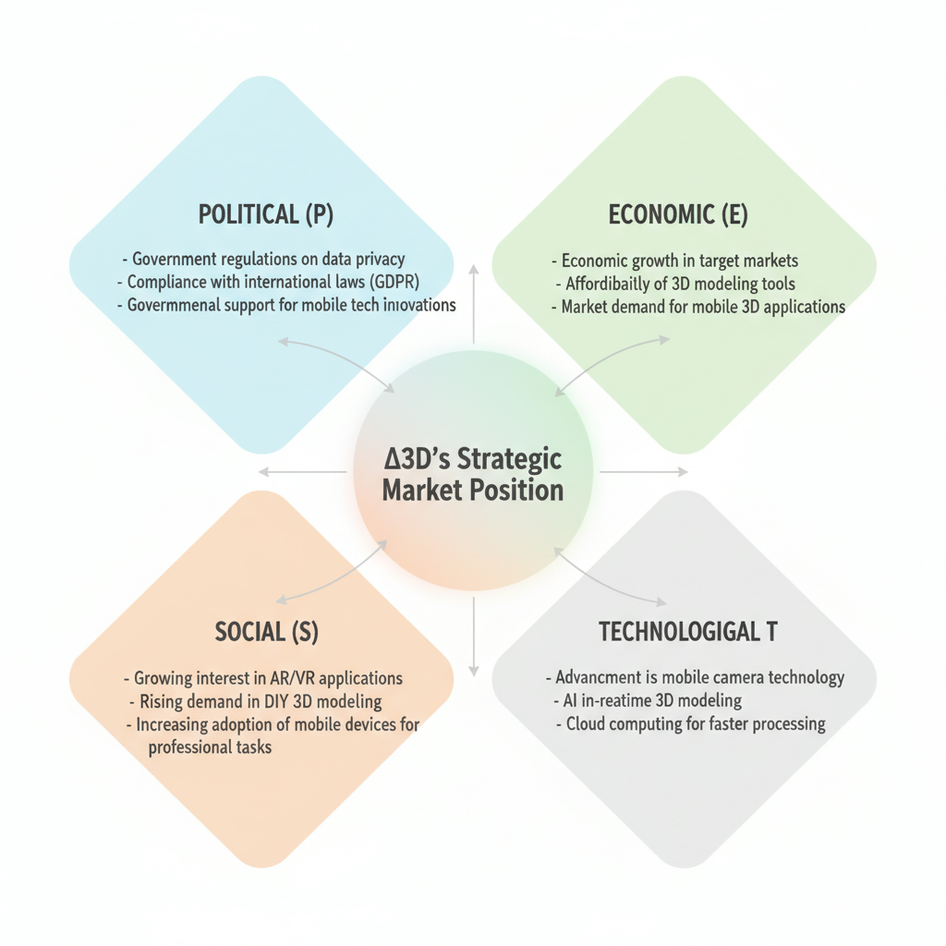

Fig13: Delta3D PEST Analysis Diagram

**5.1 Digital Marketing Channels**

**5.1.1 App Store Optimization (ASO)**

In the Chinese market, the dominant app stores are **Huawei AppGallery, Tencent MyApp, Xiaomi Mi Store, OPPO App Market, and Vivo App Store**. To increase visibility and app downloads, the ASO strategy will be tailored to each platform's search behavior and algorithms. Specific measures include:

1. **Keyword Optimization:** By researching hot keywords such as **3D modeling, AR/VR content, and mobile 3D scanning**, we will ensure the app's title, description, and tags are aligned with user searches to improve its ranking on these platforms.
2. **Update Frequency and Review Management:** Regular app updates and managing user reviews are critical for improving rankings. Actively responding to user feedback and maintaining a high rating will enhance trust and encourage downloads.
3. **App Screenshots and Videos:** We will optimize app screenshots and functional demonstration videos to effectively communicate the app's core value and attract potential users.
4. **Policy Compliance:** ASO strategies must comply with each platform's content and privacy policies. For instance, platforms like **Huawei AppGallery** **and MyApp** require apps to adhere to local regulations and protect user privacy (e.g., GDPR, China’s Personal Information Protection Law).

**5.1.2 Social Media Marketing**

Users in China are highly active on social media platforms such as **Douyin, Xiaohongshu, WeChat, and Weibo**. The content marketing strategy will include:

1. **Short Videos and Social Engagement:** By posting creative videos and user-generated content (UGC) on **Douyin and Xiaohongshu**, we will showcase the app's usage in real-world scenarios. Collaborations with well-known influencers will amplify brand exposure and drive engagement.
2. **WeChat Groups and Public Accounts:** Leveraging **WeChat Official Accounts** **and WeChat Groups**, we will create a community where users can share experiences and receive updates. Regularly posting technical articles and usage tips will keep the community active and engaged.
3. **Weibo Hashtags and Event Marketing:** By hosting online events or launching hashtag campaigns (e.g., #3DModelingChallenge), we can increase the app’s visibility and attract user participation.

**5.1.3 Search Engine Marketing**

Search engine marketing (SEM) will be an essential strategy for boosting app visibility:

1. **Baidu Advertising and Keyword Ads:** We will run targeted ads on **Baidu** using keywords like **3D modeling, AR/VR, and mobile scanning** to attract relevant users. Information flow ads will also be optimized for better click-through and conversion rates.
2. **SEO Optimization:** We will improve the app's website's SEO ranking on **Baidu** and other search engines by creating high-quality blog content, user cases, and product information. Building backlinks and improving authority will drive organic traffic.
3. **Bing and Google Ads:** For international markets, especially where Google is accessible, **Bing and Google** ad campaigns will focus on **PPC and SEO** strategies. Targeting specific keywords such as 3D modeling tools and virtual reality will help attract potential users.
4. **Compliance and Data Protection:** All SEM efforts will adhere to platform regulations and local laws, particularly those concerning data privacy (e.g., China’s Personal Information Protection Law and GDPR).

**5.1.4 Content Marketing**

Content marketing strategies, including technical blogs, tutorial videos, and case studies, will enhance the app's brand image and demonstrate its practical value:

1. **Technical Blogs and Industry Articles:** Regularly publishing articles on **Zhihu, CSDN, and Jianshu** about 3D modeling and AR/VR applications will increase the app's visibility within the tech community and attract professional users.
2. **Tutorial Videos and Case Studies:** We will produce tutorial videos to help users quickly learn how to use the app. Platforms like **Bilibili and Douyin** will be used to showcase user experiences and detailed tutorials.
3. **User Stories and Case Studies:** By sharing success stories and user experiences, we will demonstrate the app's real-world applications, such as how e-commerce sellers use 3D models to improve product presentations.

**5.2 Partnership Channels**

**5.2.1 Educational Institution Partnerships**

Partnering with educational institutions is a significant channel for promoting the app. By collaborating with universities, vocational training centers, and online education platforms, we can introduce the app to a wide student audience, particularly those in design, art, and architecture fields. Specific collaboration methods include:

1. **Campus Promotion Events:** Partnering with design courses or workshops in universities such as **Tsinghua University’s Academy of Fine Arts or Central Academy of Fine Arts**, we can organize technical seminars, software training, and design competitions to allow students to experience the app in practice. This can significantly increase adoption rates among students.
2. **Discounted Student Plans:** Offering free or discounted subscription plans to students and educators can incentivize them to use and promote the app to their peers. These discounts will not only help students access advanced design tools but also drive word-of-mouth promotion, boosting brand awareness.
3. **Online Education Platform Collaboration:** Partnering with platforms like **NetEase Cloud Classroom and Tencent Classroom**, we can offer app-based courses that teach students 3D modeling skills. By offering certified courses, we can attract users interested in learning 3D modeling and building a strong user base.

**5.2.2 Design Tool Integration**

To increase the app’s applicability and competitiveness in the market, integrating with existing design tools and platforms is key. This collaboration not only expands the app’s user base but also enhances the user experience through seamless workflows. Specific methods include:

1. **Integration with AutoCAD, SketchUp:** Collaborating with mainstream design software such as **AutoCAD, SketchUp, and Revit** to enable data compatibility or plugin development. Users can import their designs from these platforms directly into our app for 3D modeling. This integration, through partnerships with Autodesk or Trimble, will create a seamless workflow for professional designers, improving user convenience.
2. **API Integration with Design Platforms:** By opening up the app’s APIs, we can integrate with other design platforms (such as **Figma or Canva**), allowing designers to quickly create and showcase 3D models. This integration not only positions the app as an independent tool but also as a core plugin in the design industry, enhancing its penetration.

**5.2.3 E-commerce Platform Partnerships**

As e-commerce platforms increasingly focus on user experience, 3D product display has become an important tool for merchants. Collaborating with e-commerce platforms to provide 3D display solutions will create a more immersive shopping experience and improve product conversion rates. Specific methods include:

1. **Partnership with Alibaba and JD.com:** Partnering with **Taobao, Tmall, and JD.com** to offer 3D product display solutions for merchants. Sellers can use our app to convert their products into 3D models, which can then be showcased on e-commerce platforms to enhance the shopping experience and drive conversion.
2. **Collaboration with Cross-Border E-commerce Platforms:** Collaborating with platforms like **AliExpress and Amazon China**, we can provide 3D display solutions for sellers, improving their product display quality and attracting more international buyers.
3. **B2B E-commerce Platform Partnerships:** Partnering with B2B platforms like **Alibaba International** to offer 3D display tools for large enterprises. This will help businesses showcase large equipment or machinery, attracting more commercial customers.

**5.2.4 Hardware Manufacturer Partnerships**

Partnerships with hardware manufacturers can significantly increase the app’s visibility and user base, particularly in terms of pre-installation and recommendation. Specific methods include:

1. **Pre-installation with Phone Manufacturers:** Partnering with phone manufacturers like **Huawei, Xiaomi, and OPPO** to pre-install our app on newly released smartphones or recommend it in their app stores. Deep cooperation with these manufacturers allows us to reach a large new user base, especially among younger smartphone users.
2. **Recommendation Collaborations:** In addition to pre-installation, we can collaborate with manufacturers to have our app featured in the recommended list based on users’ habits and preferences. This increases app downloads and boosts user engagement.
3. **Hardware Promotion Bundling:** For example, bundling the app with new phone models for promotional offers, providing exclusive discounts or bonuses. This type of promotion will incentivize users to purchase smartphones and increase app downloads.

**5.3 Community and Word-of-Mouth Marketing**

**5.3.1 User-generated content incentive programs**

User-generated content (UGC) is one of the most effective ways to drive brand awareness and user engagement. By encouraging users to create and share content related to the app, we can build strong brand loyalty and word-of-mouth effects within the community. Specific incentive measures include:

1. **Creative Reward Programs:** Set up reward programs to encourage users to share their 3D models. For example, hosting regular **3D modeling competitions** and offering in-app premium features (such as unlocking advanced tools or providing free subscriptions) to winning users. This motivates users to participate and share their creations, further boosting brand engagement.
2. **Social Media Content Sharing:** Encourage users to share their 3D creations on platforms like **Douyin, Weibo, and WeChat**. Shared content can increase exposure through platform interactions (likes, comments, shares), attracting more users to download the app. This sharing initiative is expected to increase monthly new user downloads by **15%-20%.**
3. **Creator Incentive Programs:** For highly active users, we can design a "Creator Incentive Program" where users earn points, levels, or even cash rewards for generating original content. This boosts community engagement and encourages interaction among users.

**5.3.2 Professional reviews and media coverage**

Collaborating with industry media, professional reviewers, and KOLs can significantly enhance the app's credibility and market recognition. Specific strategies include:

1. **Media Reviews and Collaborations:** Partner with well-known tech media (e.g., **TechCrunch China, 36Kr, Huxiu**) for comprehensive app reviews. These reviews will highlight the app’s features and innovations in the 3D modeling and AR/VR sectors. Media exposure helps potential users understand the unique value of the app.
2. **Professional Bloggers and Expert Reviews:** Work with tech bloggers and industry experts to conduct in-depth product reviews and recommendations. For example, collaborating with **Zhihu** influencers specializing in 3D modeling or AR technologies to publish detailed articles or videos on the app’s performance and usage.
3. **Online and Offline Media Coverage:** Through both online self-media and offline industry exhibitions, we can increase the app’s visibility. For example, showcasing the app at **CTO Tech Summit or Product Design Expo** will help position the app as a leader in the field.

**5.3.3 Industry exhibitions and technical sharing**

Industry exhibitions and technical sharing events are crucial for expanding industry networks and increasing brand exposure. We plan to leverage these events to boost brand recognition and market credibility.

1. **Participating in Industry Exhibitions and Tech Conferences:** Attend events such as **CES Asia (Consumer Electronics Show), Shenzhen Design Week**, and other relevant exhibitions to showcase the app's latest features and technological innovations. These events provide valuable opportunities to connect with industry professionals, potential users, and partners.
2. **Hosting Technical Seminars and Workshops:** Organize or participate in technical seminars, where we share insights on 3D modeling, AR/VR technologies, and user experience optimization. This will help position the brand as a leader in the field while attracting developers and designers to use the app.
3. **Live Streaming and Social Media Events:** During exhibitions, we can use platforms like Douyin or Bilibili to live-stream the event, showcasing the app’s features in real-time and interacting with online viewers. This will further enhance user engagement and brand recognition.

**5.3.4 Influencer collaboration programs**

Partnering with influencers and KOLs can effectively amplify brand exposure, especially among younger audiences. Specific strategies include:

1. **Collaborating with Influencers and Bloggers:** Collaborate with well-known influencers and KOLs in the design and technology sectors (e.g., Zhihu creators, Weibo design experts). They can share their experiences and highlight the app’s features, attracting a larger user base.
2. **Social Media Challenges with Influencers:** Work with influencers on Douyin and Weibo to launch 3D modeling challenges, encouraging users to upload their creations. Offering rewards and promoting unique in-app features will further stimulate participation and user acquisition.
3. **KOL Co-branded Campaigns:** Collaborate with KOLs for co-branded campaigns, where influencers perform live product reviews or create promotional videos. These campaigns will increase the app’s visibility and expand its reach through the KOLs’ follower base.

**5.4 Marketing Budget Allocation**

**5.4.1 Investment proportion planning for each channel**

To achieve optimal market promotion results, the marketing budget will be allocated reasonably according to the expected effectiveness of different marketing channels. The budget allocation will be evaluated based on each channel’s ROI, market scale, and user growth potential. The planned investment proportion is as follows:

* **Digital Marketing (40%):** Given the wide reach and precise targeting of digital platforms, **40%** of the total budget will be allocated to digital marketing. Specifically, **social media marketing (30%)** will be the main investment channel, including ads and content creation on Douyin, Xiaohongshu, and Weibo. It is expected to drive **20%-30%** user growth.
* **Search Engine Marketing (20%):** Through Baidu, Bing, and Google, targeted keyword advertising will account for **20%** of the budget. This strategy is expected to drive **15%-20%** user growth through **PPC** and SEO efforts. SEO investments will focus on improving the app's natural ranking on search engines.
* **Social Media Platform Partnerships and KOL Marketing (15%):** Collaborations with KOLs and well-known bloggers will take up **15%** of the budget. Working with influencers for product reviews and promotions will drive **10%-15%** user growth, especially through Douyin and Weibo.
* **Partnership Channels (15%):** Collaborating with educational institutions, e-commerce platforms, and hardware manufacturers will account for **15%** of the total budget. **E-commerce** **partnerships** (such as with Taobao and JD.com) will be a priority, offering 3D display solutions to merchants to increase app usage.
* **Industry Exhibitions and Offline Activities (10%):** Attending industry exhibitions (such as **CES Asia**) and technical sharing events will account for **10%** of the budget. These events will serve as important channels for brand exposure, directly connecting with potential users and partners.

**5.4.2 ROI expectations and monitoring indicators**

To ensure the proper use of the marketing budget and return on investment, we will monitor the ROI through the following key performance indicators (KPIs):

* **Customer Acquisition Cost (CAC):** The cost of acquiring a new user through each channel will be measured. We expect the CAC for digital marketing and social media platforms to remain under **50 CNY**. This will help evaluate the efficiency of each channel.
* **Customer Lifetime Value (LTV):** The LTV tracks the long-term value a customer brings, factoring in subscription fees, in-app purchases, and customer retention. We expect the LTV to reach **300 CNY**. An increase in LTV will reflect higher user loyalty and conversion rates.
* **User Activation and Retention Rates:** We aim for **60%** user activation and **50%** retention within **30 days** for users acquired through social media and KOL promotion. These metrics will help assess the effectiveness of different marketing channels and make necessary adjustments.
* **Advertising Conversion Rate:** Through Baidu and Google ad campaigns, we expect an advertising conversion rate of **2%-3%**, which will be an important indicator to evaluate the effectiveness of advertising investments.
* **Market Share:** Through continuous optimization, we expect the app's market share to reach **5%-10%** in the first year of marketing, with steady growth in the following years.

**5.4.3 Phased marketing focus adjustment strategies**

Marketing strategies will be adjusted based on user feedback and market conditions to ensure effective use of funds and maximize market coverage.

Specific adjustment strategies include:

1. **Initial Phase (0-6 months): Brand Awareness and User Acquisition**

In this phase, the main goal is to increase brand awareness and attract initial users. The majority of the budget will be spent on social media ads, search engine marketing, and collaborations with educational institutions. User acquisition and brand exposure will be prioritized.

**Adjustment Strategy:** If social media marketing exceeds expectations, additional budget will be allocated to these channels to expand brand influence.

1. **Mid-Term Phase (6-12 months): User Conversion and Retention**

After building the user base, the focus will shift to improving user retention and conversion. Content marketing investments will increase to provide more technical blogs, tutorial videos, and case studies to boost engagement and satisfaction.

**Adjustment Strategy:** Based on LTV and CAC metrics, we will adjust the ad budget. If LTV grows rapidly, we will invest more in user retention strategies.

1. **Late Phase (12 months onwards): Market Penetration and Brand Leadership**

In this phase, we will focus on consolidating the market position through enhanced partnerships with e-commerce platforms and hardware manufacturers. Industry exhibitions and technical sharing will be key to strengthening brand leadership.

**Adjustment Strategy:** If market penetration is lower than expected, additional investments in KOL collaborations and industry events will be considered to increase professional credibility.

**6. Channels to Validate an App**

**6.1 User Testing Validation**  
To ensure that Δ3D meets the needs and expectations of its target audience, a thorough user testing validation process will be implemented. This includes:

* **Beta Version User Feedback Collection**: During the beta phase, a group of early adopters, including designers, e-commerce sellers, and creative users, will be invited to test the app. Feedback will be gathered on various aspects, such as ease of use, 3D scanning accuracy, model export options, and the overall user experience. This feedback will be crucial in identifying areas of improvement and ensuring that the app’s features align with user needs.
* **A/B Testing Core Functionalities**: A/B testing will be used to compare different versions of key features, such as the 3D scanning process, user interface elements, and model preview options. This will help determine which configurations perform best in terms of user engagement and satisfaction. For example, different scanning methods (e.g., using LiDAR vs. standard camera scanning) could be tested to gauge their impact on model accuracy and user preference.
* **User Experience Optimization Iteration**: Based on feedback from beta testing and A/B testing, the app’s user interface and functionality will be iteratively improved. This includes fine-tuning the user flow, simplifying complex features, and ensuring a smooth experience for users with different levels of technical expertise. Frequent updates will be rolled out during this phase to address pain points and enhance the app’s usability.

**6.2 Market Validation Methods**  
In addition to user testing, market validation is essential to assess the app's potential in the competitive landscape and ensure its relevance to the target audience.

* **MVP (Minimum Viable Product) Testing**: A basic version of Δ3D will be launched with core features such as 3D scanning, model preview, and export functionality. The purpose of this MVP is to validate market demand and test the app’s appeal to the target audience. By analyzing user interactions and retention rates, the team can determine whether there is sufficient interest and identify any features that need to be added or refined.
* **Target User Group Research**: Detailed research will be conducted on the primary target user groups (e-commerce sellers, designers, educators, and casual users). This will involve surveys, focus groups, and interviews to understand their pain points, 3D modeling needs, and feature preferences. This research will help refine the product’s value proposition and guide future feature development.
* **Competitive Feature Comparison Validation**: A thorough analysis will be conducted comparing the features of Δ3D with other 3D scanning apps and professional 3D modeling software. This will help identify areas where Δ3D can provide superior value or where competitors may offer more advanced functionalities. The goal is to ensure that Δ3D offers a competitive edge in terms of price, ease of use, and performance.

**6.3 Technical Validation Approaches**  
Ensuring the app’s performance, security, and compatibility across devices is crucial for its success.

* **Cross-device Compatibility Testing**: Δ3D will be tested across a wide range of Android devices to ensure compatibility with different screen sizes, hardware specifications, and Android versions. This includes using both physical devices and emulators (such as Kobiton, Testin, and Firebase) to evaluate how the app performs on various devices, including budget-friendly smartphones, mid-range models, and high-end devices.
* **Performance Benchmark Testing**: The app’s performance will be rigorously tested to ensure smooth 3D scanning, real-time processing, and model rendering. Key metrics, including app loading times, 3D model generation speed, and frame rates during model preview, will be measured. This testing will help identify bottlenecks and areas for optimization, ensuring that the app performs efficiently, even under heavy usage.
* **Security and Privacy Protection Validation**: Data security and privacy are critical aspects of any mobile app, particularly one that collects user-generated content. Δ3D will undergo thorough security testing to identify vulnerabilities, including those related to user data, payment information (if applicable), and cloud storage. The app will comply with industry standards for data protection (such as GDPR for users in the EU) and ensure that users’ personal data and 3D models are securely stored and transmitted. The app will also be tested for potential security risks, including secure authentication (via OAuth tokens) and data encryption.

**7. Financial Key Metrics for Mobile App Business Plan**

**7.1 Revenue Model**

**7.1.1 Freemium model**

**Freemium Model**

The Freemium model is designed to attract a large user base by offering a free version of the app and monetizing through the sale of additional premium features or services. This model works well for a broad audience, especially users who wish to try basic features before upgrading.

* **Free Features and Premium Services:** The app will offer basic 3D modeling functions and templates for free. Advanced features, such as high-end rendering effects, cloud storage, and professional editing tools, will be available as paid items. Users can either subscribe or pay for individual features.
* **Free User Conversion Rate:** By optimizing the app's core features and user interface, we aim to increase the conversion rate of free users to paid users. The expected conversion rate is **5%-10%,** meaning that for every 100 free users, 5 to 10 users are expected to become paying customers.
* **Market Validation and Optimization:** We will regularly optimize the free and paid feature differentiation through A/B testing to ensure that free users experience sufficient value, motivating them to upgrade to premium features.

**7.1.2 Subscription service fees**

The subscription model generates revenue by charging a monthly or annual fee for access to ongoing app updates, professional features, and premium services. This model provides stable and recurring revenue, with a high customer lifetime value (LTV).

* **Different Subscription Plans:** We will offer a **Basic, Premium, and Enterprise** subscription plan. The Basic plan will offer basic functionalities, while the Premium plan will provide more advanced features, such as AR/VR support, high-quality 3D rendering, etc. The Enterprise plan will offer customized solutions and team collaboration tools. Pricing will vary based on user needs and market conditions.
* **Expected Revenue:** Based on market research, we expect **20%** of users to opt for the Premium subscription, mostly creative professionals (designers, photographers, etc.). For example, the Premium subscription will be priced at **99 CNY per month**, and we expect to generate around **1 million CNY** in revenue in the first year.
* **User Growth and Conversion Rate:** By attracting a large number of free users through advertising and content marketing, we aim for a conversion rate of **10%-15%** to paid subscriptions. This will result in a steady stream of subscription revenue, which will grow as the user base expands.

**7.1.3 Enterprise version licensing**

The Enterprise version licensing will cater to large clients and teams, offering customized services, such as cross-department collaboration, enhanced feature modules, and dedicated technical support. This revenue model targets business customers, such as design firms and manufacturers, who require large-scale 3D modeling tools.

* **Customized Features and Support:** The Enterprise version will offer customized feature modules based on client needs, such as enhanced data processing power, exclusive cloud storage, and dedicated technical support teams. Pricing will be tailored based on the client's size, feature requirements, and level of support needed.
* **Pricing Model:** The Enterprise version will be priced on an annual subscription basis, with a fee of approximately **50,000 CNY per year** (depending on company size and feature needs). We expect to generate **3 million CNY** in Enterprise version revenue in the first year through partnerships with design firms and manufacturing enterprises.
* **Long-Tail Effect and Client Expansion:** Once signed, enterprise clients will generate recurring revenue. Due to the larger scale of these clients, we expect positive word-of-mouth effects, driving additional enterprise customers to join.

**7.1.4 Advertising revenue sharing**

The advertising revenue-sharing model applies to users who are unwilling to pay but still prefer to support the app through advertisements. By providing a platform for advertisers, we will earn a share of the advertising revenue.

* **Ad Formats:** Ads will include **interstitial ads, video ads, and native ads.** These ads will be displayed to free users while they use the app. The ads will be targeted based on user behavior data (e.g., usage time, interests).
* **Expected Revenue:** Based on CPM (cost per thousand impressions) and CTR (click-through rate), we expect to generate **100,000-200,000 CNY** per month from advertisements. As the user base grows, advertising revenue will increase steadily, becoming a stable source of income.
* **Advertising Partners:** We will collaborate with major advertising platforms such as **Baidu Ads, Tencent Ads, and Toutiao Ads,** using precision targeting to maximize ad revenue sharing.

**7.2 Key Financial Indicators**

**7.2.1 Customer Acquisition Cost (CAC)**

Customer Acquisition Cost (CAC) measures the cost to acquire a new user, which includes marketing, advertising expenses, and sales team efforts. Monitoring CAC will help optimize spending and marketing channel efficiency.

1. **Calculation Method:** The formula for calculating CAC is:

$$\text{CAC}\text{=}\frac{\text{Marketing} \text{Expenses}\text{+}\text{Sales} \text{Expenses}}{\text{New} \text{Customers} \text{Acquired}}$$

For example, if we spend **100,000 CNY on Douyin** ads and acquire **2,000 new users**, the CAC would be:

$$\text{CAC}\text{=}\frac{\text{100,000}}{\text{2,000}}\text{=50 }\text{CNY}\text{/}\text{user}$$

1. **Optimization Measures:** By refining ad targeting strategies and improving the ad click-through rate (CTR), we aim to reduce CAC by **10%-15%**. Optimizing content and targeting will improve the overall efficiency of the marketing spend.
2. **Expected Goal:** In the initial phase, we expect the CAC to range between **50-80 CNY**, and with increasing brand recognition, CAC will gradually decrease to below **30 CNY**.

**7.2.2 Customer Lifetime Value (LTV)**

Customer Lifetime Value (LTV) measures the total revenue a customer generates over their entire relationship with the app. LTV is a crucial indicator for predicting the app's long-term profitability.

1. **Calculation Method:** The formula for calculating LTV is:

$$\text{LTV}\text{=}\text{Average} \text{Purc}\text{h}\text{ase} \text{Value}\text{×}\text{Purc}\text{h}\text{ase} \text{Frequency}\text{×}\text{Customer} \text{Lifetime}$$

For example, if a user subscribes to a plan worth **99 CNY** per month, purchases **12 times a year**, and their expected lifetime is **2 years**, the LTV will be:

$$\text{LTV}\text{=99×12×2=2,376 }\text{CNY}$$

1. **Growth Strategy:** To increase LTV, we will:

* **Improve Retention:** Provide excellent user support and regular updates to keep users engaged, thus increasing their lifetime value.
* **Encourage Paid Upgrades:** Diversify our freemium model and subscription plans to increase the percentage of paying users.

1. **Expected Goal:** Initially, we expect the LTV to be between **2000-2500 CNY** per user, and as user retention improves, LTV is expected to exceed **3000 CNY**.

**7.2.3 Monthly Active Users (MAU)**

Monthly Active Users (MAU) measures the level of engagement and active use of the app, indicating its popularity and market penetration. The growth of MAU is closely related to user retention, market promotions, and product feature iterations.

1. **Calculation Method:** MAU is calculated based on the number of unique users who actively engage with the app within a given month. We will track MAU using analytics tools like **Google Analytics and Mixpanel.**
2. **Growth Strategy:**

* **Increase Retention:** By providing frequent feature updates, promotional activities, and social interaction features, we aim to boost user retention.
* **Social Sharing:** Encourage users to share their 3D modeling works and participate in social media challenges, increasing both user engagement and visibility.

1. **Expected Goal:** In the early stages, we expect MAU to reach **50,000** and grow to over **100,000** within six months as marketing efforts intensify.

**7.2.4 In-app Purchase Conversion Rate**

In-app purchase conversion rate measures the percentage of free users who convert to paying customers. It reflects users' willingness to upgrade to premium features. Increasing this conversion rate is key to ensuring profitability and growth.

1. **Calculation Method:** The formula for conversion rate is:

$$\text{Conversion} \text{Rate}\text{=}\frac{\text{Paying} \text{Users}}{\text{Total} \text{Users}}\text{×100\%}$$

For example, if there are **50,000** users in a month, and **5,000** make a paid purchase, the conversion rate would be:

$$\text{Conversion} \text{Rate}\text{=}\frac{\text{5,000}}{\text{50,000}}\text{×100\%=10\%}$$

1. **Optimization Measures:** To improve the conversion rate, we will:

* **Optimize Premium Features:** Ensure that premium features are clearly differentiated and provide substantial value to users.
* **Guided Purchase:** Offer previews or trial periods for paid content to encourage users to make purchases.

1. **Expected Goal:** We expect to increase the in-app purchase conversion rate to **10%-12%** initially, and through continuous optimization of features and user experience, it will gradually reach **15%-20%.**

**7.3 Profitability Projections**

**7.3.1 First-Year User Growth and Revenue Forecasts**

In the first year of app promotion, we expect rapid and stable user growth. Revenue will mainly come from the **Freemium model, Subscription service fees, and Advertising revenue.** The specific forecasts are as follows:

1. **User Growth Forecast:**

* **Initial User Acquisition:** We plan to acquire a large user base initially through social media marketing, search engine ads, and KOL collaborations. In the first year, we aim to reach **100,000** users, with **30%** of them becoming active users (MAU).
* **Paid User Conversion Rate:** Through the Freemium model, we expect a **10%-12%** conversion rate of free users to paid users, resulting in approximately **10,000** paying users in the first year.

1. **Revenue Forecast:**

* **Freemium Model Revenue:** Of the free users, **10%-12%** are expected to convert to paid users, with an annual revenue of **200 CNY** per paying user. The expected revenue from **10,000** **paying users** will be:
$$\text{10,000×200=2,000,000}\text{CNY}$$

* **Subscription Service Fee Revenue:** Based on market research, we expect **20%** of users to opt for the Premium subscription, generating around **50,000 CNY** in monthly subscription revenue (with a monthly subscription fee of **99 CNY**). The annual revenue from subscriptions will be:
$$\text{50,000×99×12=5,940,000}\text{CNY}$$

* **Advertising Revenue:** We expect to generate around **100,000 CNY** in monthly advertising revenue, bringing in an annual total of:

$$\text{100,000×12=1,200,000}\text{CNY}$$

1. **Total Revenue Forecast:** Combining the above sources, the total revenue for the first year is expected to be:

$$\text{2,000,000+5,940,000+1,200,000=9,140,000}\text{CNY}$$

**7.3.2 Three-Year Financial Planning**

Based on the growth achieved in the first year, revenue is expected to grow steadily in the second and third years. The specific financial plan is as follows:

1. **Second Year Forecast:**

* **User Growth:** We anticipate a **150% increase** in the user base, reaching **250,000** users. Paid user conversion will rise to **15%-18%,** resulting in **45,000** paid users.
* **Revenue Growth:** With the increase in paid users and stable subscription revenue, the expected total revenue in the second year is:

$$\text{45,000×200+150,000×99×12+200,000×12=20,000,000}\text{CNY}$$

1. **Third Year Forecast:**

* **User Growth:** The user base is expected to double in the third year, reaching **500,000** users. Paid users are expected to reach **100,000**.
* **Revenue Growth:** The total revenue in the third year is projected to be:

$$\text{100,000×200+300,000×99×12+400,000×12=40,000,000}\text{CNY}$$

1. **Total Revenue Over Three Years:** The cumulative revenue over the first three years is expected to be:

$$\text{9,140,000(}\text{Year}\text{1)+20,000,000(}\text{Year}\text{2)+40,000,000(}\text{Year}\text{3)=69,140,000}\text{CNY}$$

**7.3.3 Break-even Point Analysis**

The break-even point (BEP) represents the point at which total revenue equals total costs. Calculating the break-even point will help determine how many users and revenue are needed to cover initial investment and operational costs.

1. **Fixed Costs:** Fixed costs include development, server fees, employee salaries, and marketing expenses. We estimate the total fixed costs for the first year to be **3 million CNY,** with second and third-year fixed costs rising to **5 million CNY and 8 million CNY,** respectively, due to increased user base and operations.
2. **Variable Costs:** Variable costs mainly include user support, advertising costs, and cloud storage. We estimate the variable cost per user to be **10 CNY.**
3. **Break-even Point Calculation:**

The formula for calculating the break-even point is:

$$\text{BEP}\text{=}\frac{\text{Fixed} \text{Costs}}{\text{Gross} \text{Profit} \text{per} \text{User}}$$

* Using the **Freemium model,** the gross profit per paid user is **200 CNY annually**. Thus, the break-even point in Year 1 will be:
$$\text{BEP}\text{=}\frac{\text{3,000,000}}{\text{200×0.95}}\text{≈15,789 }\text{paid} \text{users}$$

* This means we need around **15,800 paying users** in the first year to cover costs and break even.

**7.4 Funding Requirements**

**7.4.1 R&D Investment Budget**

Research and development (R&D) is the core to ensuring continuous product innovation and maintaining competitiveness. To constantly enhance the app’s functionality, performance, and user experience, we will allocate significant funds for R&D. The R&D budget will cover technical development, product iteration, system optimization, and team expansion.

1. **Budget Allocation:**

* **Technical Development:** The core technologies include the 3D modeling engine development, rendering engine, and AR/VR integration. The expected budget for R&D in the first year is **5 million CNY,** mainly used for core function development, algorithm optimization, and technical iterations. The second and third years will see an increase in R&D investment to **8 million CNY and 12 million CNY,** respectively, as product features expand.
* **Technical Team Building:** To support ongoing development and optimization, we plan to hire **3-5 senior developers** and strengthen the existing technical team. The budget for team building is expected to be **2 million CNY.**

1. **R&D Goals:**

* The first year will focus on developing a stable core 3D modeling engine and user interface, ensuring users can smoothly use basic features.
* In the second year, the focus will shift to integrating AR/VR functions and improving 3D rendering.
* By the third year, the focus will be on enhancing system scalability, stability, and developing user-customized features.

1. **Funding Sources:**

* The R&D budget will primarily come from initial funding rounds and reinvestment from revenue.
* R&D will account for about **20%-30%** of the total budget.

**7.4.2 Marketing and Promotion Budget**

Marketing and promotion are essential for driving user growth and market share. A significant portion of the budget will be allocated to both online and offline brand promotional activities to attract more users and enhance brand recognition.

1. **Budget Allocation:**

* **Digital Marketing:** This includes advertising on social media platforms, search engines, and collaborations with KOLs. The marketing budget for the first year is projected to be **12 million CNY, with 18 million CNY and 25 million CNY** for the second and third years, respectively. As brand awareness increases, marketing expenditure will rise to maintain user growth.
* **Content Marketing:** This involves creating and promoting technical blogs, tutorial videos, case studies, etc. Content marketing will account for **30%** of the total marketing budget, with the first-year budget at **3.6 million CNY,** growing in subsequent years.
* **Partnership Channels and Exhibitions:** Collaborations with educational institutions, e-commerce platforms, and hardware manufacturers, as well as participation in industry exhibitions, will account for **5 million CNY** annually.

1. **Marketing Strategies:**

* In the early phase, most of the budget will be allocated to **social media platforms** (Douyin, Weibo, etc.) and KOL collaborations.
* In the later phases, focus will shift to **content marketing and industry exhibitions** to further solidify the brand’s market presence.

1. **Funding Sources:**

* The marketing budget will be supported by project funding and reinvestment from revenue.

**7.4.3 Operations and Maintenance Costs**

Operations and maintenance costs include server expenses, technical support, daily management, and customer service. As the user base grows, operating costs will increase accordingly.

1. **Budget Allocation:**

* **Server and Cloud Storage:** The expected server and cloud storage costs in the first year are **3 million CNY, rising to 5 million CNY and 8 million CNY** in the second and third years due to increasing user data storage needs.
* **Customer Support and Service:** Customer support team expenses will be **1 million CNY** in the first year, with costs increasing to **1.5 million CNY and 2 million CNY** in the second and third years due to the growing user base.

1. **Operational Goals:**

* Initial phase will focus on infrastructure setup and optimizing user support.
* In the second phase, the focus will shift to data analytics and operational management system building.

1. **Funding Sources:**

* Operating costs will be supported by revenue reinvestment and operating capital.

**7.4.4 Team Expansion Plan**

To support the rapid growth of the business and technical innovation, team expansion will be a key part of the strategy. We will focus on expanding the development, marketing, and customer support teams.

1. **Budget Allocation:**

* **Technical Team Expansion:** The technical team will grow as R&D needs increase. The budget for expanding the technical team in the first year is **5 million CNY**, with an additional **2 million CNY** in the second year.
* **Marketing Team Expansion:** To improve marketing efficiency, we will hire **3 marketing managers** in the first year and expand to 5 by the second year. The budget for expanding the marketing team is **2 million CNY**.
* **Customer Support Expansion:** The customer support team will grow with the user base, with plans to hire **5 customer service staff** in the first year. The expansion budget for customer support is **1 million CNY.**

1. **Expansion Goals:**

* In the first phase, the focus will be on expanding the technical team to ensure product development and optimization.
* In the second phase, we will focus on building the marketing and customer support teams to support growth and user acquisition.

1. **Funding Sources:**

* The team expansion funds will be supported by revenue reinvestment, shareholder funding, and external financing.

1. **Risk Assessment and Mitigation**

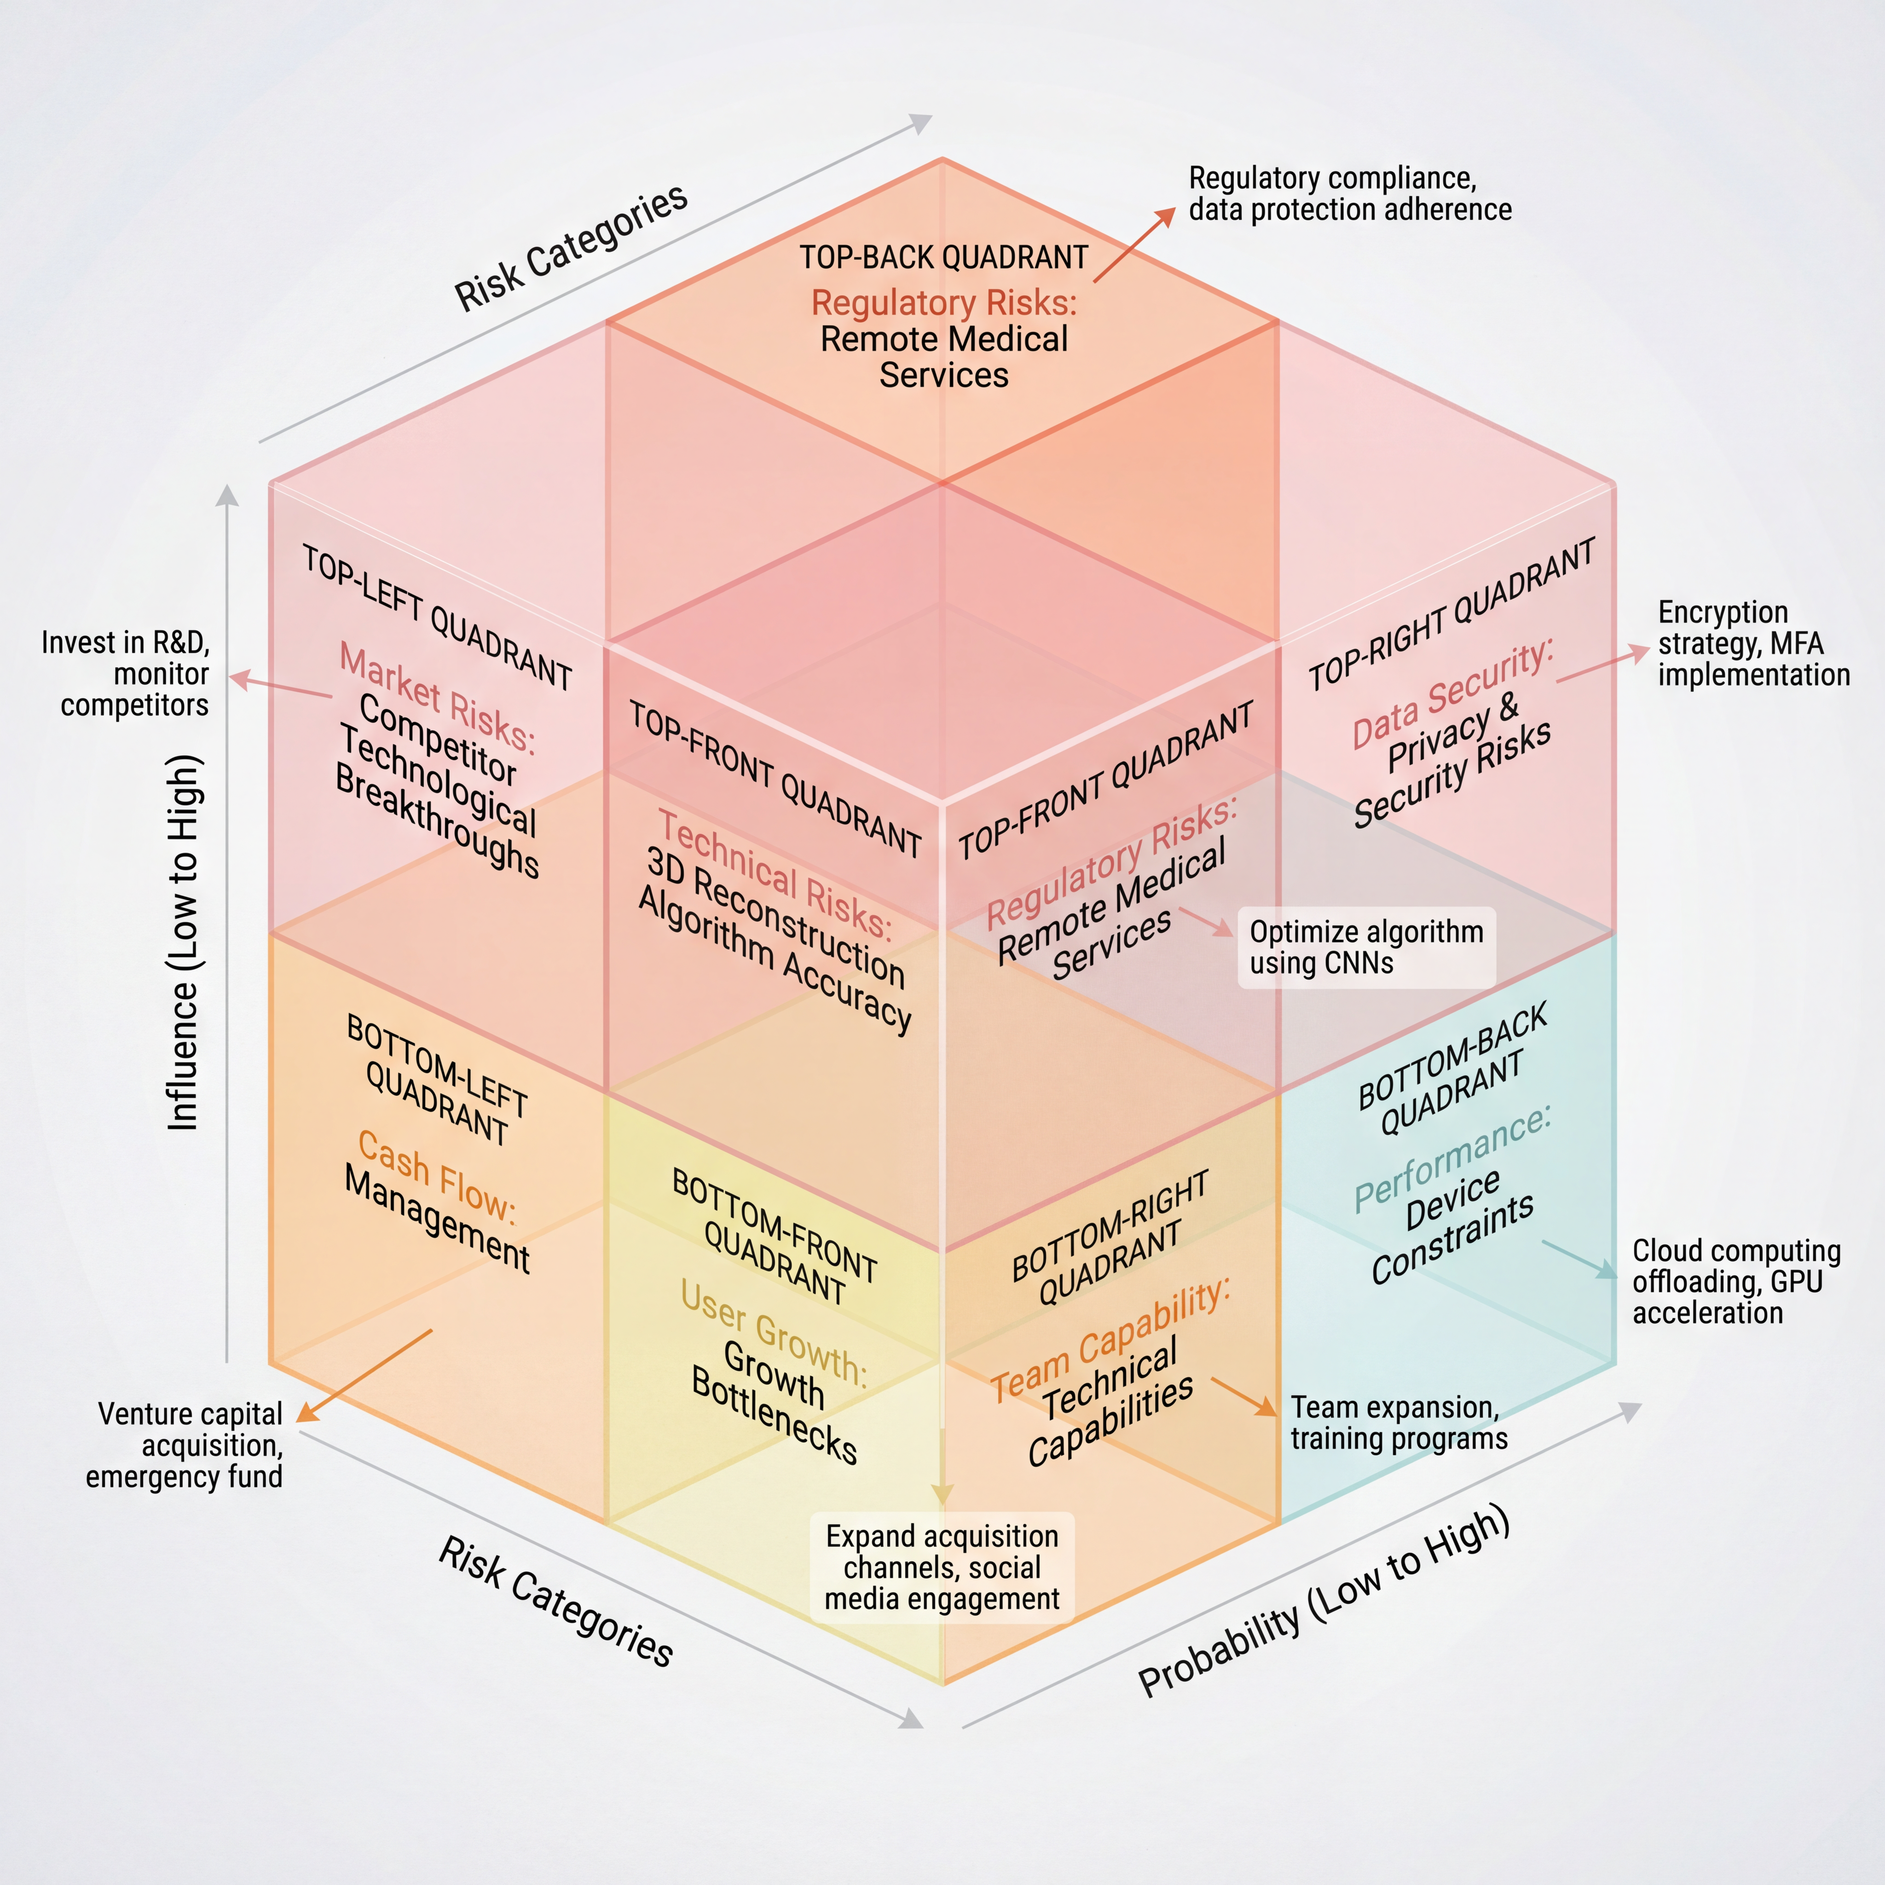

Fig14: Risk Matrix for 3D Modeling App

**8.1 Technical Risks**

| **Risk Category** | **Risk Description** | **Mitigation Strategies** | **Quantitative Goal** |
| --- | --- | --- | --- |
| 3D Reconstruction Algorithm Accuracy Limitations | The 3D reconstruction algorithm's accuracy and performance may be affected by hardware, algorithm limitations, and image quality, leading to suboptimal user experience. | 1. Optimize algorithm using CNNs and multi-view data. 2. Data augmentation for different scenarios.   3. Set a target to reduce error rate below 5%. | Target to reduce the error rate to below 5% in two years. |
| Mobile Device Performance Constraints | Mobile devices, especially lower-end devices, may struggle with the computational demands of 3D modeling and rendering, leading to performance issues such as lag. | 1. Optimize app for different device configurations, using GPU acceleration and step-by-step rendering. 2. Provide a 'light version' for lower-end devices.   3. Use cloud computing for heavy tasks. | Ensure 80% of lower-end devices can run the app smoothly. Utilize cloud computing to offload computationally intensive tasks[11]. |
| User Data Security Protection | The security of user data, including personal and payment information, may be compromised if proper data protection measures are not in place. | 1. Implement AES-256 encryption for data storage and transmission. 2. Ensure compliance with data protection regulations (e.g., PIPL).   3. Implement Multi-Factor Authentication (MFA) for enhanced account security. | Ensure full compliance with data protection laws. Target at least 99.9% of sensitive data encryption and protection. |

**8.2 Market Risks**

| **Risk Category** | **Risk Description** | **Mitigation Strategies** | **Quantitative Goal** |
| --- | --- | --- | --- |
| Competitor Technological Breakthroughs | Competitors may introduce technological innovations (e.g., AI-driven 3D modeling, real-time rendering) that intensify market competition and disrupt our market position. | 1. Invest in continuous R&D, focusing on AI and real-time rendering. 2. Monitor competitor activities through a competitive intelligence team.   3. Differentiate through market segmentation and tailored solutions. | Increase market share to 10%-15% within three years through innovation and market segmentation. |
| Changes in User Demand | Shifting user preferences and evolving industry demands (e.g., VR/AR for e-commerce, real-time editing) can impact app relevance and adoption. | 1. Conduct regular user research and market trend analysis. 2. Implement agile product iteration to rapidly adapt to new user needs.   3. Engage with users through social media and community platforms. | Respond to 10%-20% of changing user demands within two years by improving user retention and satisfaction. |
| Policy and Regulatory Impacts | Policy and regulatory changes, particularly concerning data privacy laws (e.g., PIPL), could affect data handling, app features, and market access. | 1. Ensure compliance with data protection regulations (PIPL). 2. Maintain strong relationships with regulatory bodies to stay informed.   3. Regular legal audits to ensure data security and privacy. | Achieve 100% compliance with regulatory standards and swiftly adapt to policy changes. |

**8.3 Operational Risks**

| **Risk Category** | **Risk Description** | **Mitigation Strategies** | **Quantitative Goal** |
| --- | --- | --- | --- |
| Team Technical Capabilities | As the project scales, the existing team may struggle to meet the fast-paced iteration needs, and a lack of senior talent could cause delays in progress. Additionally, the team's ability to continue innovating may be compromised. | 1. Expand the technical team by hiring 10 senior experts in the next two years. 2. Provide internal and external training programs to enhance team capabilities.   3. Partner with external R&D companies to introduce new technologies. | Improve team capabilities within 12 months and achieve 3 technological innovations within 24 months. |
| Cash Flow Management | In the expansion phase, expenditures may exceed revenue, causing cash flow pressure. If external financing is not secured, the company may face cash flow shortages. | 1. Implement monthly cash flow forecasting and budgeting. 2. Seek venture capital and equity financing to support the growth phase.   3. Establish an emergency fund pool for unexpected expenses. | Ensure positive cash flow within 6 months and raise at least 5 million CNY in external funding within 12 months. |
| User Growth Bottlenecks | User acquisition, retention, and conversion rates are essential for growth. Bottlenecks may occur if we rely on limited acquisition channels or struggle to retain and convert free users into paying users. | 1. Expand user acquisition channels through collaborations with e-commerce platforms, educational institutions, and KOLs. 2. Increase user retention with gamification features and social interactions.   3. Improve paid conversion rates through membership benefits and promotions. | Overcome growth bottlenecks, reaching 100,000 MAU within 12 months, with 50% retention rate and 15% paid conversion rate. |

**9.Implementation Timeline**

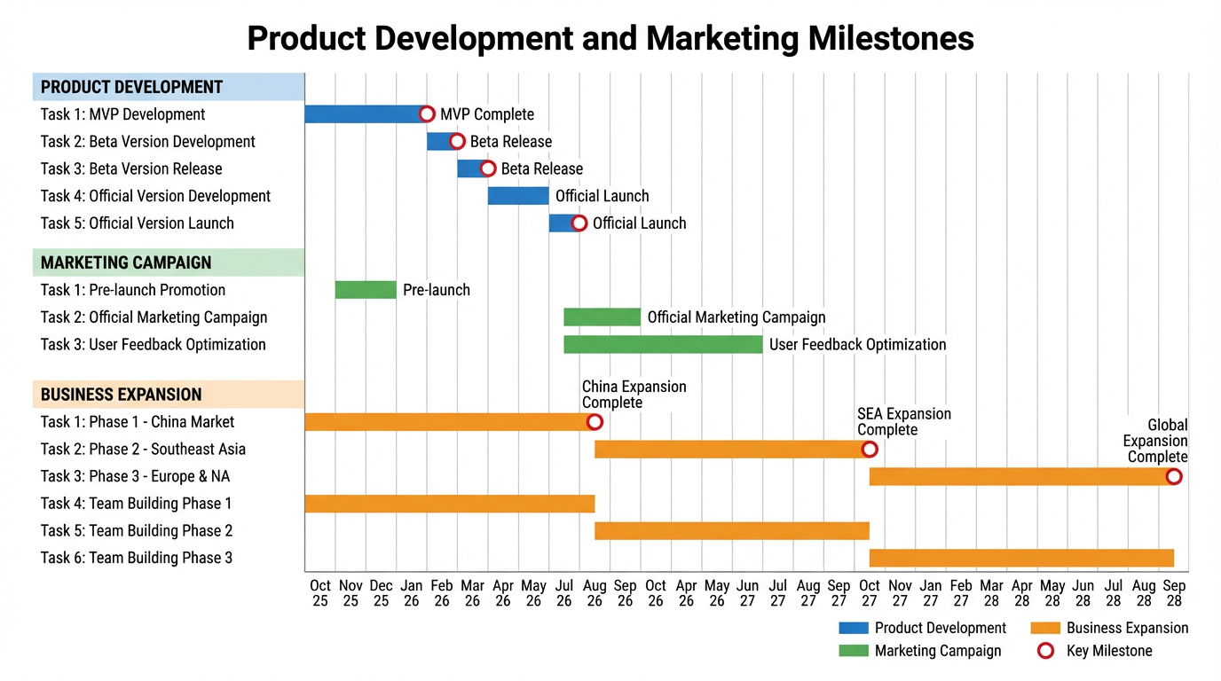

Fig15: Product Development and Marketing Milestones

**9.1 Product Development Milestones**

To ensure the product is launched on time and is competitive in the market, we will develop a detailed product development plan and set key milestones. Below are the plans and goals for each phase.

**9.1.1 MVP Development Completion Timeline**

**Goal:** The MVP (Minimum Viable Product) is the foundation for verifying whether the core product features meet user needs. In this phase, we will focus on developing the most basic 3D modeling functionality, user interface, and preliminary user interaction experience.

**Timeline:**

* Month 1: Complete product requirement analysis and feature definition, identify the core MVP features, such as 3D modeling, user registration/login, and basic feature display.
* Month 2-3: Develop the core features of the MVP version and conduct initial functionality testing and optimization to ensure basic functions are stable.
* Month 4: Conduct internal testing, gather feedback, fix bugs, and optimize performance. The goal is to complete MVP development by the end of Month 4 and conduct a small-scale user test.

The goal for this phase is to complete the MVP version by Month 4 and prepare for user validation.

**9.1.2 Beta Version Release Plan**

**Goal:** The Beta version is intended to provide a real experience for a subset of users and gather feedback. This phase will further improve functionality, fix issues identified in the MVP phase, and add more user interaction designs.

**Timeline:**

* Month 5: Expand functionality based on the MVP version, including social interaction, model saving, and sharing features. Complete the initial development of the Beta version.
* Month 6: Release the Beta version to 1,000-2,000 target users, gather user feedback, and focus on issues such as user interface, interaction experience, and 3D modeling accuracy.
* Month 7: Optimize the Beta version, fix bugs based on user feedback, and perform system performance testing to ensure the app runs smoothly on different devices. Prepare for the official release.

The goal of the Beta version is to refine the product through user feedback, ensuring that the official version meets market needs. We expect to launch the optimized Beta version by Month 7.

**9.1.3 Official Version Launch Schedule**

**Goal:** The official version will be a fully developed, stable, and feature-complete version that is ready for official release and market promotion. The release of the official version will ensure all core features, UI/UX design, performance, and security are fully tested and optimized.

**Timeline:**

* Month 8: Based on feedback from the Beta phase, improve product functionality and optimize performance to ensure high stability and security.
* Month 9: Complete final product testing, ensure smooth operation on all major devices, and begin pre-launch marketing. Conduct a small-scale pre-release activity to build anticipation.
* Month 10: Officially launch the 1.0 version of the app, widely promote it through advertising and KOL collaborations. The goal is to achieve 50,000 downloads by the end of Month 10 and expand the user base further.

The goal for this phase is to launch the product to the market and gain positive user feedback, gradually building a user base and continuously improving the user experience through optimizations and iterations.

**9.2 Marketing Campaign Milestones**

To ensure the app successfully attracts users and achieves the desired market impact, we will set a detailed marketing campaign plan with key milestones. These milestones will help ensure smooth execution and effective results for each marketing phase.

**9.2.1 Pre-launch Promotion Initiation**

The pre-launch promotion phase is essential for creating user anticipation and market awareness ahead of the official release. During this phase, we will engage in various online and offline activities to capture the attention of our target audience and generate excitement for the official launch.

**Activity Details:**

* Social Media Promotion: Before the official release, we will promote the app through platforms like Douyin, Weibo, releasing feature teasers, developer interviews, and product highlights to generate user interest.
* KOL Collaboration: Collaborating with relevant industry influencers (KOLs) to showcase the app's features and reviews, boosting its visibility on social media.
* Early Bird Incentives: We will offer early bird rewards, such as VIP feature trial or discounts for the first month, to encourage early sign-ups and create excitement around the app.

**Timeline:**

* The pre-launch promotion will start 2 months before the official release and run for 4-6 weeks, ensuring broad coverage across multiple channels and platforms.
* The goal is to attract 50,000 sign-ups during the pre-launch phase, with an expected 20% user conversion rate.

**9.2.2 Official Marketing Campaign Launch**

The official marketing campaign is the key phase to drive user growth and increase market share. This phase will combine online advertising, offline events, and partner promotions to maximize product exposure, downloads, and user engagement.

**Activity Details:**

* Online Advertising: We will use Baidu, Douyin, WeChat Ads and other platforms to run targeted ad campaigns, focusing on core features and driving downloads and registrations.
* Social Media Engagement: Utilize Weibo topics, Douyin challenges, and other social media campaigns to encourage users to share their 3D models, creating viral engagement and increasing user activity.
* Offline Events and Exhibitions: Participate in industry-related design and technology exhibitions, showcasing the product, distributing promotional materials, and building brand recognition within the industry.

**Timeline:**

The official marketing campaign will begin within 1 week of the official product launch and continue for 3 months.

The goal is to attract at least 100,000 new users within 3 months, with an initial market share goal of 10%-15%.

**9.2.3 User Feedback Optimization Cycles**

User feedback is vital for ongoing product improvement and optimization. By regularly gathering feedback, we can better understand user needs, pain points, and preferences, leading to continuous product refinement.

**Activity Details:**

* User Surveys and Questionnaires: Regular surveys to gather insights on user experience, feature requests, and feedback. The data will be analyzed to address user concerns and make necessary improvements.
* Customer Support and Communication: Strengthen the customer support team to ensure timely responses and solve user issues, while recording common problems for future product iterations.
* Social Media and Community Interaction: Engage actively with users on social media platforms, respond to queries, and build stronger relationships with the user community.

**Timeline:**

The user feedback optimization cycles will run for 6 months after the product launch, with bi-monthly surveys and iterative product updates.

The goal is to increase user satisfaction to 80% and improve user retention to 60%-70% within this period.

**9.3 Business Expansion Planning**

**9.3.1 Feature Iteration and Update Schedule**

As market demand and technological advancements evolve, the iteration and update of product features are essential to maintaining competitiveness. We will develop a clear product update roadmap and release new versions regularly based on user feedback, market trends, and technological development.

**Feature Update Plan:**

* **Short-term (within 6 months):** Improve core functionalities, such as 3D modeling accuracy, user interaction, and interface design. For example, we will introduce AR/VR support to enhance the immersive user experience and improve 3D rendering speed.
* **Medium-term (within 1 year):** After enhancing core features, we will add innovative features such as social interaction, allowing users to share and discuss 3D models, and provide enterprise customization for B2B clients.
* **Long-term (within 2 years):** Based on industry trends and technological development, we plan to introduce advanced features like AI-assisted modeling and panoramic VR presentations to meet the needs of high-end users.
* **Update Frequency:** We will release updates every 2-3 months, ensuring efficient product iteration while maintaining a high development speed.

**Quantitative Goal:**

* Launch AR/VR support within 6 months, aiming for 50% active user adoption.
* Introduce social interaction features within 12 months, increasing user engagement to 70%.

**9.3.2 Market Expansion Timeline**

To expand market share and enter more verticals, we will develop a detailed market expansion timeline, gradually promoting the app in more regions and industries to grow our user base.

**Market Expansion Plan:**

* **Phase 1 (Within 1 year):** Launch the app in major cities in China (e.g., Beijing, Shanghai, Guangzhou) through online advertising, social media promotion, and industry exhibitions to increase brand recognition and user acquisition speed.
* **Phase 2 (Within 2 years):** After establishing the product in China, expand to Southeast Asia (e.g., Singapore, Thailand, Malaysia), where mobile internet penetration is high, and there is demand for 3D modeling and AR/VR.
* **Phase 3 (Within 3 years):** Enter the European and American markets, offering localized versions tailored to specific national needs and expanding quickly through international partnerships.

**Quantitative Goal:**

* **Year 1:** Achieve 30% annual growth in China, reaching 100,000 users by the end of the first year.
* **Year 2:** Enter Southeast Asia and attract 50,000 users, building brand presence.
* **Year 3:** Expand into the European and American markets, aiming for 100,000 users by the end of the third year.

**9.3.3 Team Building Progress**

Team building is fundamental to supporting long-term business growth. As business expands and market demands increase, we need to continuously expand our team, especially in critical areas such as R&D, marketing, and customer support.

**Team Expansion Plan:**

* **Phase 1 (Within 1 year):** Hire 3 senior engineers for deep learning, GPU acceleration, and 3D rendering, and 2 marketing managers to handle market expansion.
* **Phase 2 (Within 2 years):** Expand the team to 10 senior technical experts, including front-end, back-end, and AI engineers. The marketing team will grow to 5 members, and we will establish a dedicated user growth department.
* **Phase 3 (Within 3 years):** With the global market expansion, the team will further grow, with plans to hire 5 overseas market managers responsible for local promotion in Europe, North America, and Southeast Asia.

**Team Goals:**

* Hire at least 3 senior technical staff within 6 months to complete the first phase of team expansion.
* Hire 5 marketing personnel within 1 year to accelerate market share growth.
* Complete the global expansion team within 2 years.

**10. Success Metrics and KPIs**

| **Metric** | **Definition** | **Target Measurement** | **Quantitative Goals** |
| --- | --- | --- | --- |
| Daily Active Users (DAU) / Monthly Active Users (MAU) | DAU refers to the number of unique users who use the app daily. MAU refers to users who have used the app at least once within a month. | Achieve 20,000 DAU and 100,000 MAU within 3 months; maintain DAU/MAU ratio over 20% within 6 months. | 20,000 DAU in 3 months, 100,000 MAU. |
| Session Duration and Frequency | Session duration refers to the average time users spend per session. Session frequency refers to how often users open the app. | Achieve 15-20 minutes session duration per user within 6 months; maintain 3 sessions per day. | 15-20 minutes session duration, 3 sessions per day. |
| Feature Adoption Rate | Feature adoption rate refers to the usage rate of different features within the app. | Achieve 40% adoption rate for new features within 3 months. | 40% adoption rate for new features. |
| User Retention Rate | User retention rate refers to the percentage of users who continue to use the app after a specific time period (Day 1, Day 7, Day 30). | Achieve 40% Day 7 retention and 25% Day 30 retention within 6 months. | 40% Day 7 retention, 25% Day 30 retention. |

**10.1 User Engagement Metrics**

**10.2 Business Performance Indicators**

| **Metric** | **Definition** | **Target Measurement** | **Quantitative Goals** |
| --- | --- | --- | --- |
| Revenue Growth Rate | Revenue growth rate measures the percentage increase in revenue over time, reflecting market appeal and profitability. | Achieve 40% growth in revenue in Year 1, 50% growth in Year 2, mainly from user expansion and paid subscriptions. | Achieve 10 million CNY revenue in Year 1, 15 million CNY in Year 2. |
| Customer Acquisition Efficiency | Customer Acquisition Cost (CAC) measures the average cost to acquire a new customer, indicating marketing efficiency. | Achieve CAC under 300 CNY in the first 3 months, optimize acquisition efficiency through marketing channels. | Reduce CAC by 20% within 6 months. |
| Market Share Progression | Market share measures the percentage of total sales or users captured in a specific market, reflecting competitive strength. | Capture 5% market share in China in Year 1, expand to 10% in Year 2, and 5% in Southeast Asia by Year 3. | Achieve 10% market share in China by Year 2, 5% market share in Southeast Asia by Year 3. |
| Brand Recognition Metrics | Brand recognition measures the level of awareness and influence the brand has within the target market. | Achieve 50% brand recognition in 6 months, 70% brand recognition in 12 months. | Achieve 70% brand recognition in 12 months. |

**10.3 Technical Performance Metrics**

| **Metric** | **Definition** | **Target Measurement** | **Quantitative Goals** |
| --- | --- | --- | --- |
| App Performance Benchmarks | App performance benchmarks include response time, load speed, and system resource usage to ensure smooth performance across devices. | Startup time under 3 seconds, response time under 500ms, memory usage under 200MB, and CPU usage below 30%. | Startup time < 3 seconds, response time < 500ms, memory < 200MB, CPU usage < 30%. |
| Crash Rates and Bug Reports | Crash rate refers to the frequency of app crashes during use, while bug reports refer to errors and issues reported by users. | Keep crash rate under 1% within the first 3 months; fix 90% of bugs within 48 hours of reporting. | Crash rate < 1%, bug fix rate 90% in 48 hours. |
| 3D Model Quality Ratings | 3D model quality ratings include model accuracy, texture quality, and rendering quality, based on user feedback and professional reviews. | Achieve 4.5/5 rating for 3D models on average within 6 months, especially focusing on texture precision and detail rendering. | Achieve 4.5/5 average rating for models within 6 months. |
| Processing Speed Optimization | Processing speed refers to the time taken to perform tasks like 3D modeling, rendering, and image processing, with the goal of reducing delays. | Complete model generation and rendering within 30 seconds; ensure 80% of users experience minimal delays during operation. | Model rendering time < 30 seconds, 80% of users experience minimal delay. |

1. **Future Roadmap**

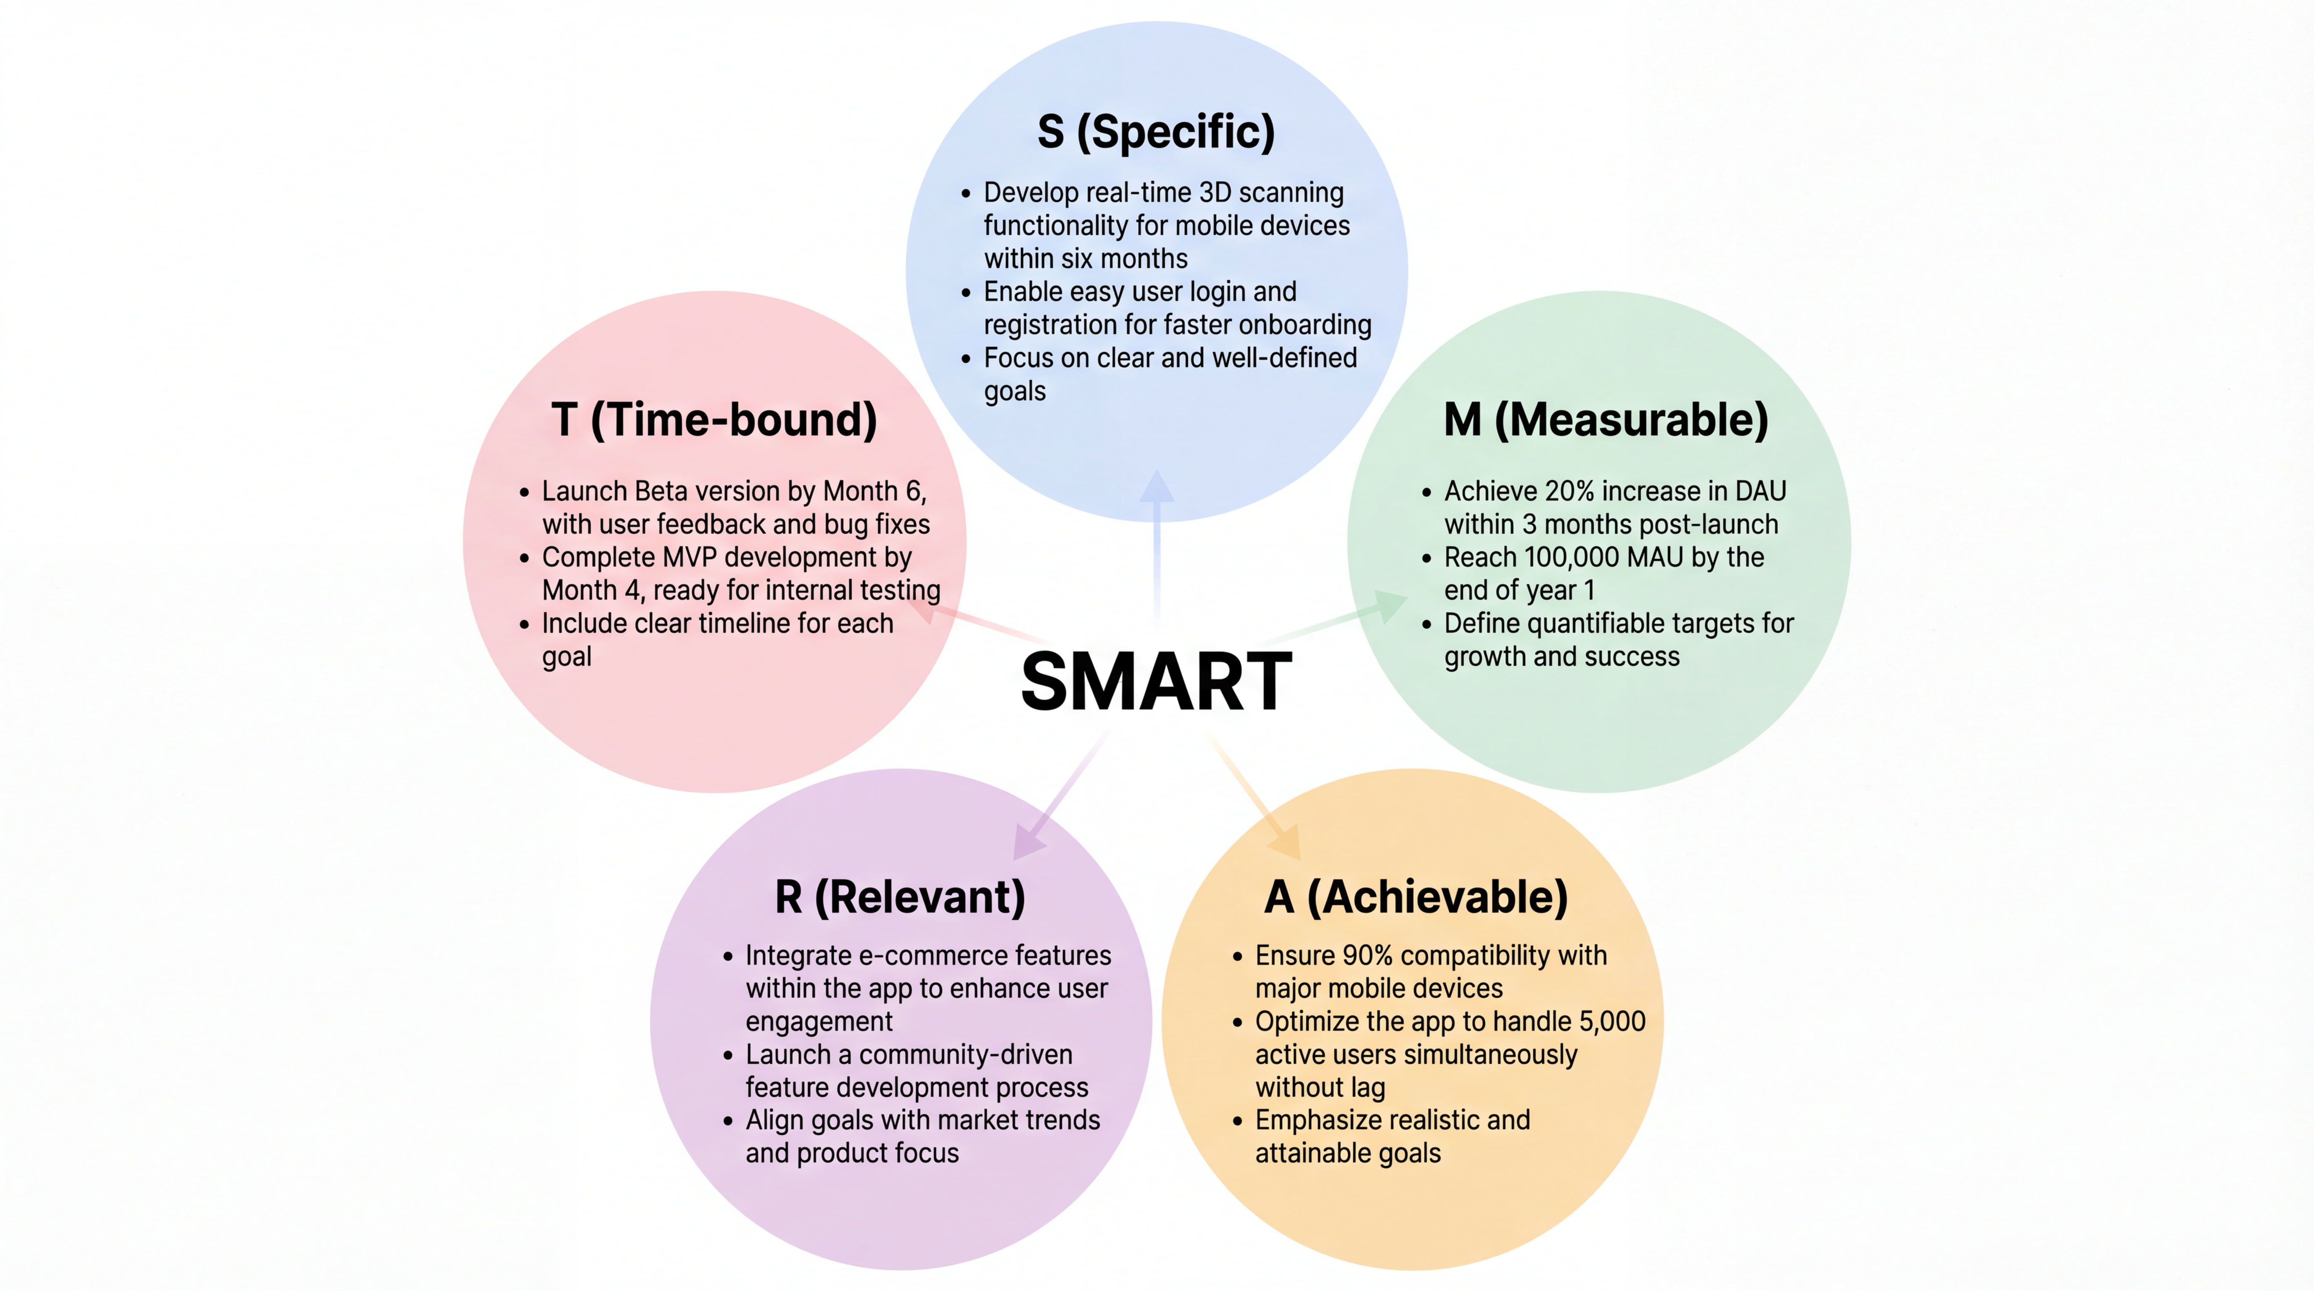

Fig16: Delta3D SMART Analysis Diagram

**11.1 Product Evolution**

Product evolution is a core component of our long-term strategy, focusing on continuous optimization and expansion based on technological innovations, user needs, and industry developments. We will gradually introduce new technologies, enhance existing features, improve the user experience, and ensure that the product remains competitive in a fast-evolving market.

**11.1.1 Advanced AI Integration Plans**

* **Goal:** Integrate advanced AI algorithms to enhance the automation of 3D modeling and improve model quality, particularly in complex scenes.
* **Implementation:** We plan to develop and integrate a deep learning-based 3D modeling assistant system within the next 12 months, utilizing Convolutional Neural Networks (CNN) to optimize model details, especially in texture and fine rendering.
* **Quantitative Goals:** By integrating AI-assisted modeling, we aim to improve model accuracy by 30%, reducing the need for manual intervention, and within 18 months, we expect AI-assisted features to become a core capability, serving over 40% of active users.

**11.1.2 Multi-platform Expansion Strategy**

* **Goal:** Expand the application to support additional platforms, including a Web version, Desktop version, and iOS version.
* **Implementation:** Launch the iOS version within 6 months, followed by synchronized updates with the existing Android version. Within the next 12 months, release an online 3D modeling tool for web browsers to provide a seamless, cross-platform experience.
* **Quantitative Goals:** By the end of 2 years, we aim to achieve 40% cross-platform user adoption, expanding the market further by offering desktop and web-based services.

**11.1.3 Enterprise Solution Development**

* **Goal:** Provide customized 3D modeling solutions for medium and large enterprises to meet their needs in product design, virtual displays, and digital transformation.
* **Implementation:** We plan to develop an enterprise-specific version within 12 months, offering additional enterprise features such as multi-user collaboration, high concurrency support, and cloud storage. This version will also include customizable enterprise interfaces to support bulk data processing.
* **Quantitative Goals:** Our goal is to acquire at least 100 enterprise clients by the end of 2 years, including industries such as manufacturing and construction, and generate 30% of total revenue from enterprise solutions.

**11.2 Market Expansion**

To ensure our app achieves success globally, we will develop a comprehensive market expansion plan. This plan will focus on international market entry, establishing strategic partnerships, and specializing in industry verticals. Through these efforts, we aim to rapidly capture market share and provide customized solutions to users in different regions and industries.

**11.2.1 International Market Entry**

Expanding into international markets is a key step for globalizing the product. By entering various countries and regions, we can expand brand influence and grow the user base. We will prioritize markets with high demand for 3D modeling and AR/VR technologies.

1. **Target Markets:** Initially, we will focus on the Southeast Asia market (e.g., Singapore, Thailand, Malaysia) and European and American markets, which have significant demand for mobile internet and 3D modeling.

* **Southeast Asia Market:** Given the high mobile device penetration and demand for emerging technologies in this region, we plan to launch a localized version for Southeast Asia within 12 months.
* **European and American Markets:** We will expand to Europe and North America in 2 years, with a particular focus on industries such as architecture, game development, and virtual reality.

1. **Market Penetration Plan:** We will ensure high exposure in the target markets through partner marketing, social media ads, online and offline promotions.

* **Quantitative Goal:** By the end of Year 1, we aim to have 50,000 active users in Southeast Asia; by the end of Year 3, we expect to acquire 100,000 users in Europe and North America.

**11.2.2 Strategic Partnership Opportunities**

Building strong strategic partnerships is essential to rapidly entering new markets and expanding market share. By collaborating with industry leaders, platforms, and service providers, we will leverage their resources and channels to accelerate market penetration.

1. **Technology Partners:** Collaborate with companies like Unity and Autodesk to integrate their design tools and 3D modeling platforms, enhancing our technological capabilities and market presence.

* **Implementation:** Establish a 3D modeling tool integration partnership with Unity to provide cross-platform 3D modeling and rendering support.
* **Quantitative Goal:** We expect to increase user conversion rates by 30% through Unity integration, particularly in the game development and VR industries.

1. Industry Partners: Partner with e-commerce platforms, educational institutions, and leading design firms to provide customized 3D display and design tools.

* **Quantitative Goal:** Through partnerships with platforms like Taobao and JD.com, we expect to help e-commerce sellers improve 3D display conversion rates by 40% within the first year.

**11.2.3 Industry Vertical Specialization**

In addition to expanding into international markets, we will focus on specific industry verticals, offering customized solutions to meet the specific needs of various industries. This vertical market strategy will enhance our competitive advantage and attract professional users within those industries.

1. **Architecture and Construction Industry:** Provide 3D modeling tools tailored to architectural design firms and construction companies, supporting VR presentations and building model analysis.

* **Implementation:** Integrate Building Information Modeling (BIM) technology into the product to enhance modeling efficiency and accuracy for the construction industry.
* **Quantitative Goal:** By targeting this vertical, we aim to attract at least 1,000 architectural design firms within the first year.

1. **Game Development Industry:** Collaborate with game development companies to provide support for 3D character modeling and virtual environment creation, improving the efficiency of creating virtual assets for games.

* **Quantitative Goal:** Within 2 years, we plan to attract 50 game companies and capture 15% of the market share in the game development sector.

**11.3 Technology Innovation**

To ensure our product stays at the forefront of technology, we will focus on driving next-generation 3D scanning capabilities, AR/VR integration, and cloud computing optimization. These innovations will enhance the technical capacity of the app, improve user experience, and strengthen market competitiveness. Below are the detailed plans for each area of technology innovation.

**11.3.1 Next-Generation 3D Scanning Capabilities**

3D scanning is one of the core technologies in our app. Next-generation 3D scanning technology will further improve the precision, speed, and stability of model generation. We plan to adopt more advanced algorithms and hardware to optimize the 3D scanning experience, especially in complex environments.

1. **Goal:** Develop a high-precision, fast scanning system to improve the automation of 3D modeling and reduce manual intervention.
2. **Implementation:**

* Utilize LiDAR (Laser Imaging Detection and Ranging) technology to enhance scanning accuracy and distance, enabling precise modeling even in low-light environments.
* Combine deep learning, specifically Convolutional Neural Networks (CNN), to optimize the model's detail, focusing on textures and finer details.
* Collaborate with hardware manufacturers to launch devices equipped with high-precision scanning capabilities, such as phones integrated with LiDAR technology.

1. **Quantitative Goal:** We plan to launch an enhanced 3D scanning feature within 12 months, aiming to increase scanning accuracy by 30% and reduce scanning time by 40%[8].

**11.3.2 AR/VR Integration Roadmap**

Integrating Augmented Reality (AR) and Virtual Reality (VR) technologies will greatly enhance user experience, particularly in 3D modeling and virtual displays. We plan to incorporate AR and VR support in future versions, enabling users to view and interact with 3D models in a virtual space.

1. **Goal:** Achieve a fully immersive virtual modeling experience and integrate AR technology to provide more interactive virtual display environments.
2. **Implementation:**

* **Virtual Reality (VR):** Collaborate with VR device manufacturers to develop VR features compatible with devices such as Oculus and HTC Vive, allowing users to view and modify 3D models in a virtual environment.
* **Augmented Reality (AR):** Integrate with ARCore and ARKit to allow users to display 3D models in real time in the physical space, providing a more immersive and interactive experience.

1. **Quantitative Goal:** Within 18 months, we aim to complete the initial integration of VR/AR features, expecting 25% more interaction time from users and 15% higher user engagement.

**11.3.3 Cloud Computing Optimization**

Cloud computing is a critical technology that supports the efficient operation of 3D modeling apps, especially when dealing with model storage, rendering processing, and large-scale user access. By optimizing the cloud computing architecture, we can enhance the app’s stability, scalability, and processing speed.

1. **Goal:** Build a highly efficient and scalable cloud platform to support large-scale 3D model processing, data storage, and user requests.
2. **Implementation:**

* Adopt a microservice architecture to improve system flexibility and scalability.
* Partner with leading cloud service providers such as AWS, Google Cloud, and Microsoft Azure to offer GPU acceleration and large-scale data storage, improving rendering efficiency and processing speed.
* Introduce edge computing technology to push data processing to the user's end, reducing latency and bandwidth consumption to enhance user experience.

1. **Quantitative Goal:** By 12 months, we plan to complete the upgrade of the cloud computing architecture, ensuring a 40% improvement in rendering speed, and expand to global data centers within 2 years, supporting millions of concurrent users.

**Reference**

1. MarketsandMarkets. (2024). 3D Reconstruction Technology Market - Global Forecast to 2030.
2. 2024 Content Creator Ecosystem Report.
3. IDC. (2025, September). XR Hardware and Interactive 3D Software Market Forecast.
4. IDC China. (2025). Top 10 Predictions for China's AR/VR Market in 2025. Beijing, China: IDC China.
5. (2025). Q1 2025 Financial Results (March Quarter).
6. CNNIC. (2025). The 56th Statistical Report on China's Internet Development. Beijing, China: China Internet Network Information Center.
7. Schönberger, J. L., & Frahm, J. M. (2016). Structure-from-Motion Revisited. CVPR 2016.
8. Kato, H., & Fukui, K. (2020). Real-Time 3D Reconstruction and AR/VR Applications. Int. J. Comp. Vis.
9. Hu, X., & Zhang, T. (2021). Efficient GPU-Based Real-Time 3D Rendering for Mobile Devices. ISCGD 2021.
10. Li, Y., & Liu, Z. (2020). Cloud Computing for Real-Time 3D Modeling and Rendering. Int. J. Cloud Comput.



2025

**Business Plan**



THANKS FOR READING